|  |  |  |  |  |
| --- | --- | --- | --- | --- |
|  |  | | |  |
|  |  | | |  |
|  | Personal Portable Profiles: Auto Save Sub-Feature  <<Feature>>  (F002032) | | |  |
|  |  | | |  |
| Document Type | **Feature Document (FD)** | | |  |
| Template Version | **6.1a / FFSD 7.1** | | |  |
| SysML Report Template Version | **O Beta (9/27/2019)** | | |  |
| Document ID | **auto save feature spec - rev f.docx** | | |  |
| Document Location |  | | |  |
| Document Owner | **Patrick Brown, Evangelos Foutris, Jaime Hernandez** | | |  |
| Document Revision | **VDOC080441/F-Auto Save Feature Specification** | | |  |
| Document Status | **Draft** | | |  |
| Date Issued | **2021/03/08** | | |  |
| Date Revised | **2021/03/08** | | |  |
| Document Classification | GIS1 Item Number: | **27.60/35** | |  |
| GIS2 Classification: | **Confidential** | |
|  | | | | |
|  | | | | |
| Document Approval | | | | |
| Person | Role | | Email Confirmation | Date |
|  |  | |  |  |
|  |  | |  |  |

**Auto-Generated by MagicDraw**

Printed Copies Are Uncontrolled

# Disclaimer

**This document contains Ford Motor Company Confidential information. Disclosure of the information contained in any portion of this document is not permitted without the expressed, written consent of a duly authorized representative of Ford Motor Company, Dearborn, Michigan, U.S.A.**

**Copyright, Ó 2016 Ford Motor Company**

This document contains information developed and accumulated by and for FORD MOTOR COMPANY. As such, it is a proprietary document, which, if disseminated to unauthorized persons, would provide others with restricted information, data, or procedures not otherwise available, exposing the FORD MOTOR COMPANY to potential harm.

Employees and suppliers having custody of this specification or authorized to use it must be cognizant of its proprietary nature and ensure that the information herein is not made available to unauthorized persons.

FORD MOTOR COMPANY reserves the right to protect this work as an unpublished copyrighted work in the event of an inadvertent or deliberate unauthorized publication. FORD MOTOR COMPANY also reserves its rights under copyright laws to protect this work as a published work.

This document or portions thereof shall not be distributed outside FORD MOTOR COMPANY without prior written consent. Refer all questions concerning disclosure to the author(s) or to any duly authorized representative of Ford Motor Company.

# Contents

Disclaimer 2

Contents 3

1 Introduction 6

1.1 Document Purpose 6

1.2 Document Scope 6

1.3 Document Audience 6

1.3.1 Stakeholder List 6

1.4 Document Organization 6

1.4.1 Document Context 6

1.4.2 Document Structure 7

1.5 Document Conventions 7

1.5.1 Requirements Templates 7

1.6 References 7

1.6.1 Ford Documents 7

1.6.2 External Documents and Publications 7

1.7 Glossary 7

1.7.1 Parameters / Values 8

2 Feature Overview 9

2.1 Purpose and Description of Feature 9

2.2 Feature Variants 9

2.2.1 Regions & Markets 10

2.3 Input Requirements 10

2.3.1 Legal Requirements 10

2.3.2 Trustmark Requirements 10

2.3.3 Industry Standards 10

2.3.4 Attribute Requirements 10

2.4 Lessons Learned 11

2.5 Assumptions 12

3 Feature Context 14

3.1 Feature Context Diagram 14

3.2 List of Influences 14

4 Feature Modeling 16

4.1 Operation Modes and States 16

4.2 Use Cases 20

4.2.1 Use Case Diagram 20

4.2.2 Actors 21

4.2.3 Use Case Descriptions 22

4.3 Driving and Operation Scenarios 25

4.4 Decision Tables 26

5 Feature Requirements 27

5.1 Functional Requirements 27

5.1.1 Error Handling 36

5.2 Non-Functional Requirements 36

5.2.1 Safety 36

5.2.2 Security 36

5.2.3 Reliability 36

5.3 HMI Requirements 37

5.4 Other Requirements 38

5.4.1 Design Requirements 38

5.4.2 Manufacturing Requirements 38

5.4.3 Service Requirements 39

5.4.4 After Sales Requirements 40

5.4.5 Process Requirements 40

5.4.6 Uncategorized Requirements 40

6 Functional Safety 42

6.1 System Behaviors for HARA 42

6.2 Safety Assumptions 42

6.3 Safety Goals 42

6.4 Functional Safety Requirements 42

6.4.1 Safety Goal: Prevent Hazard (Example) 42

6.4.2 Derivation of Functional Safety Requirements on Assumptions 46

6.5 ASIL Decomposition of Functional Safety Requirements 46

6.5.1 Decomposition of Functional Safety Requirement 46

7 CyberSecurity 47

7.1 Security Goals 47

7.2 Cybersecurity Requirements 47

8 Architecture 48

8.1 Functional Architecture 48

8.1.1 List of Functions 51

8.2 Logical Architecture 51

8.2.1 Logical Elements 52

8.2.2 Logical Interfaces 58

9 Open Concerns 60

10 Revision History 61

11 Appendix 62

11.1 Definitions 62

11.2 Abbreviations 70

**List of Figures**

Figure 1: Feature Image Here 9

Figure 2: Feature Context Operational 14

Figure 3: Logical Operating Modes 2 (Active) 16

Figure 4: Logical Operating Modes (Feature) 19

Figure 5: Auto save Operation Context Use Cases 21

Figure 6: W&RC #1 Diagram – Prevent Hazard (Example) 44

Figure 7. Prevent Hazard (Example) 44

Figure 8: Protect "Active profile" Positional Settings 48

Figure 9: Retain Positional Settings Automatically 50

Figure 10: Logical Vehicle System Architecture Structure 52

Figure 11: Vehicle System Architecture 52

**List of Tables**

Table 1: Features described in this FD 6

Table 2: Ford internal Documents *(not specified in SysML model)* 7

Table 3: External documents and publications *(not specified in SysML model)* 7

Table 4: Parameters / Values used in this document 8

Table 5: Feature Variants 10

Table 6: Regions & Markets 10

Table 7: List of Influences 15

Table 8: Operation Modes and States on Logical Operating Modes 2 (Active) 17

Table 9: Transitions between Operation Modes and States on Logical Operating Modes 2 (Active) 19

Table 10: Operation Modes and States on Logical Operating Modes (Feature) 20

Table 11: Transitions between Operation Modes and States on Logical Operating Modes (Feature) 20

Table 12: List of Actors 22

Table 13: System Behaviors for HARA 42

Table 14: Functional Safety Goals 42

Table 15: Cybersecurity Goals 47

Table 16: List of Functions on Protect "Active profile" Positional Settings 51

Table 17: List of Functions on Retain Positional Settings Automatically 51

Table 18: Logical Elements 58

Table 19: Feature Interactions on Vehicle System Architecture 59

Table 20: Open Concerns *(Not supported by MagicDraw report generation)* 60

Table 21: Definitions used in this document 70

Table 22: Abbreviations used in this document 70

# Introduction

## Document Purpose

A Feature Document (FD) document specifies **what** the feature shall do and how it shall behave from customer perspective. It should also provide reasoning and background **why** we have the feature in the vehicle.

The FD also serves as an Item Definition as defined by ISO26262 for those features, which follow the Ford Functional Safety process.

To get more information about the concept of feature, function and component level abstraction refer to the [Ford RE Wiki](http://wiki.ford.com/display/RequirementsEngineering/Requirements+Engineering+for+SW+Enabled+Features). For details on the Ford Functional Safety (ISO26262) process refer to the [Ford Functional Safety Sharepoint](https://pd3.spt.ford.com/sites/GlobalFunctionalSafety/Pages/default.aspx).

## Document Scope

This Feature Document (FD) specifies the following features:

|  |  |  |  |
| --- | --- | --- | --- |
| **Feature ID** | **Feature Name** | **Owner** | **Reference** |
| F002032 | Personal Portable Profiles, which Auto Save is a part of  (Program(s): MY24 CDX746/47) | Patrick Brown, Evangelos Foutris, Jaime Hernandez | [VSEM](https://www.vsemweb.ford.com/tc/launchapp?-attach=true&-s=226TCSession&-o=jxexwXN4x3NrTDAAAAAAAAAAAAA&servername=Production_Server) |

Table 1: Features described in this FD

## Document Audience

The FD is written by the feature owner of Patrick Brown, Evangelos Foutris, Jaime Hernandez. All Stakeholders, i.e., all people who have a valid interest in the feature should read and, if possible, review the FD. It needs to be guaranteed, that all stakeholders have access to the currently valid version of the FD.

### Stakeholder List

For the latest list of stakeholder of the feature and their influence refer to [Stakeholder List for Auto Save in VSEM (VDOC085550)](https://www.vsemweb.ford.com/tc/launchapp?-attach=true&-s=226TCSession&-o=SZU9Xk_yx3NrTDAAAAAAAAAAAAA&servername=Production_Server).

## Document Organization

### Document Context

Refer to the [Specification Structure page](http://wiki.ford.com/display/RequirementsEngineering/Specification+templates) in the [Ford RE Wiki](http://wiki.ford.com/display/RequirementsEngineering/Requirements+Engineering+for+SW+Enabled+Features) to understand how the FD relates to other Ford Requirements Documents and Specifications.

### Document Structure

The structure of this document is explained below:

**Section 1** – Introduction how to use this document including responsibilities and requisite documents. Explains the terminology. Gives a clarification of the definitions, concepts and abbreviations used in the document.

**Section 2** – Feature Description. States briefly the background and the purpose of the feature, feature variants and corresponding regions and markets. Also includes input requirements, assumptions and constraints.

**Section 3** – Feature Context describes all external entities, which have an influence on the feature.

**Section 4** – Feature Modeling. Contains Use Case, Driving Scenarios, State Charts to describe the functional behavior of the feature.

**Section 5** – Safety. Lists System Behaviors and Safety Goals of the feature.

**Section 6** – Feature Requirements. Lists functional and non-functional requirements of the feature.

**Section 7** – Architecture. Shows the coarse architecture, which the feature requirements are deployed to. Describes the elements and the boundary of the feature as well as the decomposition and distribution of associated functions.

**Section 8** – List of Open Concerns

**Section 9** – Document Change History including a list of new or modified requirements. The requirements in this document are tagged, and this section contains different types of tables listing all, new, or changed requirements by their title and page no.

**Section 10** – Appendix

## Document Conventions

### Requirements Templates

Each requirement, use case or scenario in this specification shall follow the corresponding template given in the document template *Specification_Macros.dotm* at [RE Wiki - Specification Templates](http://wiki.ford.com/display/RequirementsEngineering/Specification+templates?src=contextnavpagetreemode).

#### Identification of requirements

#### Requirements Attributes

The templates provided by *Specification_Macros.dotm* define a list of attributes for each requirement. This helps to classify the requirement. The attributes are explained at [RE Wiki - Requirements Attributes](http://wiki.ford.com/display/RequirementsEngineering/Requirements+Attributes?src=contextnavpagetreemode).

## References

### Ford Documents

List here all Ford internal documents, which are directly related to the feature.

| **Reference** | **Title** | **Doc. ID** | **Document Location** | **Revision** |
| --- | --- | --- | --- | --- |
| VDOC080441 | Auto Save Feature Specification | VDOC080441 | [VSEM](https://www.vsemweb.ford.com/tc/launchapp?-attach=true&-s=226TCSession&-o=zNX5hzEYx3NrTDAAAAAAAAAAAAA&servername=Production_Server) | F |
| VDOC089611 | Auto Save Functional Specification | VDOC089611 | [VSEM](https://www.vsemweb.ford.com/tc/launchapp?-attach=true&-s=226TCSession&-o=zqsBkU6Cx3NrTDAAAAAAAAAAAAA&servername=Production_Server) | A |
| VDOC089612 | Auto Save Implementation Specification | VDOC089612 | [VSEM](https://www.vsemweb.ford.com/tc/launchapp?-attach=true&-s=226TCSession&-o=DDgBkU6Cx3NrTDAAAAAAAAAAAAA&servername=Production_Server) | A |
| VDOC075158 | PPP Feature Document | VDOC075158 | [VSEM](https://www.vsemweb.ford.com/tc/launchapp?-attach=true&-s=226TCSession&-o=iWYxEeXyx3NrTDAAAAAAAAAAAAA&servername=Production_Server) | B |
| VDOC085831 | PPP Functional Specifications | VDOC085831 | [VSEM](https://www.vsemweb.ford.com/tc/launchapp?-attach=true&-s=226TCSession&-o=h$b9Xjn8x3NrTDAAAAAAAAAAAAA&servername=Production_Server) | B |
| VDOC080627 | PPP Feature Implementation | VDOC080627 | [VSEM](https://www.vsemweb.ford.com/tc/launchapp?-attach=true&-s=226TCSession&-o=F0c5z4zQx3NrTDAAAAAAAAAAAAA&servername=Production_Server) | A |
| VDOC083702 | Classic Memory Feature Specification | VDOC083702 | [VSEM](https://www.vsemweb.ford.com/tc/launchapp?-attach=true&-s=226TCSession&-o=iaQ9AR4Cx3NrTDAAAAAAAAAAAAA&servername=Production_Server) | F |
| VDOC088610 | Classic Memory Functional Specification | VDOC088610 | [VSEM](https://www.vsemweb.ford.com/tc/launchapp?-attach=true&-s=226TCSession&-o=idlBBLxox3NrTDAAAAAAAAAAAAA&servername=Production_Server) | B |
| VDOC089667 | Classic Memory Implementation Spec | VDOC089667 | [VSEM](https://www.vsemweb.ford.com/tc/launchapp?-attach=true&-s=226TCSession&-o=SNhBkV85x3NrTDAAAAAAAAAAAAA&servername=Production_Server) | A |
| VDOC041625 | Enhanced Memory Feature Specification | VDOC041625 | [VSEM](https://www.vsemweb.ford.com/tc/launchapp?-attach=true&-s=226TCSession&-o=boRV6owSx3NrTDAAAAAAAAAAAAA&servername=Production_Server) | J |
| VDOC041626 | Enhance Memory Feature Implementation Guide (Feature Level) | VDOC041626 | [VSEM](https://www.vsemweb.ford.com/tc/launchapp?-attach=true&-s=226TCSession&-o=rkWV6owSx3NrTDAAAAAAAAAAAAA&servername=Production_Server) | H |

Table 2: Ford internal Documents *(not specified in SysML model)*

### External Documents and Publications

The list of external documents could include books, reports and online sources.

| **Reference** | **Document / Publication** | **Document Location** |
| --- | --- | --- |
|  |  |  |

Table 3: External documents and publications *(not specified in SysML model)*

## Glossary

See Appendix for Definitions and Abbreviations.

### Parameters / Values

| **Name** | **Description** | **Range / Resolution** |
| --- | --- | --- |

Table 4: Parameters / Values used in this document

# Feature Overview

## Purpose and Description of Feature

This Block represents the EOI and the Feature called Auto Save. The Auto Save feature is an enhancement of Classic Memory feature, taking the role of assists the user with seamlessly and automatically saving to the user profile any positional settings changes.

This feature would also take the role of aiding the Personal and Portable Profiles feature with protecting the positional settings of unauthorized and unwanted access and saving.

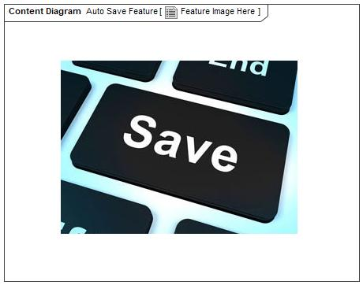

Figure 1: Feature Image Here

## Feature Variants

|  |  |  |
| --- | --- | --- |
| **Variant Name** | **Variant Description** | **Remarks** |
| **Driver Auto Save** | The Driver Auto Save feature is designed to function with any vehicle that utilizes powered positional settings for the driver. These settings can include Memory Seats, Power Pedals, Power Side Mirrors, Power Steering Column, and AHUD. Additional settings may be incorporated in future versions. Driver Auto Save will monitor these settings as the driver makes adjustments while the vehicle is running. Driver Auto Save will then determine appropriate saving behavior. In addition to saving, Driver Auto Save introduces a new repository of saved settings. Driver Auto Save will determine which saved settings will be recalled based on input from the driver and current profile factors. |  |
| **Extended Auto Save** | The Extended Auto Save feature builds upon the existing Driver Auto Save feature. It is designed to function with any vehicle that utilizes powered positional settings for both the driver and the passengers. Passengers can include occupants of the first, second, or third row who are not engaged in the operation of the vehicle. These settings are usually memory seats with lumbar support, but Extended Auto Save might include additional settings in future versions.  Extended Auto Save will monitor these settings as the user makes adjustments while the vehicle is running. Extended Auto Save will then determine appropriate saving behavior. In addition to saving, Extended Auto Save introduces a new repository of saved settings. Extended Auto Save will determine which saved settings will be recalled based on input from the user and current profile factors. |  |

Table 5: Feature Variants

### Regions & Markets

|  |  |  |  |  |  |  |
| --- | --- | --- | --- | --- | --- | --- |
| **Market /**  **Region**  Variant Name | **North America** | **South America** | **Europe** | **Middle East/Africa** | **Asia / Pacific** | **China** |
| **Driver Auto Save** | Optional | Optional | Optional | Optional | Optional | Optional |
| **Extended Auto Save** | Optional | Optional | Optional | Optional | Optional | Optional |

Table 6: Regions & Markets

## Input Requirements

### Legal Requirements

No Legal Requirements specified.

### Trustmark Requirements

No Trustmark Requirements specified.

### Industry Standards

No Industry Standards specified.

### Attribute Requirements

* STK_ASMS13 : Activate Feature
  + The vehicle should provide to the [User/Technician/Dealer] an option to activate the functionality of aiding the user with retaining positional settings.
* STK_ASMS19 : AS Diagnostics Accessible by Tech
  + The vehicle should provide to the [Technician] a method to control and diagnose any issues originating with the process of aiding the customer with retaining positional settings.
* STK_ASMS18 : Auto Save Inhibit OFF
  + When the [Valet] is no longer operating the vehicle, a Guest profile is no longer active, an Easy Entry Easy Exit event has concluded, and Portable Profiles has decided to stop inhibiting the profile, the vehicle should resume aiding the customer with retaining positional settings.
* STK_ASMS17 : Auto Save Inhibit ON
  + When the [Valet] is operating the vehicle, a Guest profile is active, an Easy Entry Easy Exit event is occurring, or Portable Profiles has decided to inhibit the profile, the vehicle should cease aiding the customer with retaining positional settings.
* STK_ASMS55 : Capturing Multiple Positional Adjustments
  + The vehicle should account for multiple positional settings adjustments in a short period in order to capture the new preferred position of the [User/Technician/Dealer].
* STK_ASMS57 : Classify Adjustment as Insignificant
  + When the [User/Technician/Dealer] makes a positional adjustment that does not significantly deviate from the previously saved position, the vehicle should save these changes.
* STK_ASMS58 : Classify Adjustment as Significant
  + When the [User/Technician/Dealer] makes a positional adjustment that significantly deviates from the previously saved position, the vehicle should provide the user the ability to retain this adjustment.
* STK_ASMS12 : Deactivate Feature
  + The vehicle should provide to the [User/Technician/Dealer]an option to deactivate the functionality of aiding the user with retaining positional settings.
* STK_ASMS53 : Disregard Undesired Changes
  + The vehicle shall provide the [User/Technician/Dealer] with the means to disregard undesired positional adjustments that significantly deviate from the previously saved position.
* STK_ASMS9 : Feature Automatically Enabled
  + When the [User/Technician/Dealer] creates a profile via any method or feature, the vehicle should enable a functionality that keeps track of positional settings and aids the user with retaining positional changes in the profile.
* STK_ASMS30 : Feature Simple
  + The method that the vehicle interfaces with the [User/Technician/Dealer] should be simple, intuitive, clear, and highly understandable.
* STK_ASMS38 : Minimal Prompts
  + The vehicle should provide minimal prompts.
* STK_ASMS64 : Minimize Save Events
  + The vehicle should minimize saving events to reduce degradation of vehicle memory.
* STK_ASMS63 : Save AHUD Positions
  + The vehicle should aid the [User/Technician/Dealer] with retaining their preferred configuration of the AHUD.
* STK_ASMS62 : Save Mirror Positions
  + The vehicle should aid the [User/Technician/Dealer] with retaining their preferred visibility settings, including the side mirrors.
* STK_ASMS67 : Save Optional Positions
  + If available, the vehicle should aid the [User/Technician/Dealer] with retaining their preferred accommodation, including steering wheel, power pedals, and lumbar support.
* STK_ASMS61 : Save Seat Positions
  + The vehicle should aid the [User/Technician/Dealer] with retaining their preferred seat accommodation.
* STK_ASMS34 : Settings Easy to Access 1
  + The vehicle should offer an accessible means for the [User/Technician/Dealer] to customize certain settings of the automatic save operation.
* STK_ASMS27 : Simple UI 1: UX Standards
  + The vehicle Feedback requests to the user shall comply with all UX standards.
* STK_ASMS28 : Simple UI 2: Accessible Feedback
  + Any instruments used to provide user feedback should be easily accessible to the [User/Technician/Dealer].
* STK_ASMS29 : Simple UI 3: Intuitive Feedback
  + Any feedback process from the vehicle to request issued to the [User/Technician/Dealer] should be clear, intuitive, and highly understandable (based on Ford UX standards).
* STK_ASMS37 : Suggest Profile Change
  + When a user utilizes another user’s profile and makes a positional adjustment that significantly deviates from the previously saved position, the vehicle should provide the user the option to change the profile to retain these adjustments separately.

## Lessons Learned

Prior to this implementation of Auto Save, Ford has made two prior attempts to automatically retain position settings. The first implementation was introduced on Lincoln vehicles in the mid 1990’s. The second implementation was introduced on the MY2013 Ford Escape. Both vehicles had significant issues that this implementation of Auto Save intends to address.

In the mid 1990’s, Ford deployed an automatic save strategy on the MY1995 Lincoln Continental and MY1997 Mark VIII. The strategy was to save every time the user made an adjustment, displaying a message on the cluster after an adjustment was made. The user could turn the feature off using a button on the seat. The major drawback of this strategy was the excessive number of memory writes that occurred, which damaged the seat memory. Addressing this excessive writing issue is one of the goals of this implementation of Auto Save.

The MY2013 Ford Escape featured an automatic saving feature that was linked to key fobs. Unlocking a vehicle with a linked fob resumed the memory settings associated with that fob. When the user exited and locked the vehicle, any changes would be automatically retained. However, this system generated a lot of customer complaints and TGWs. Fobs were permanently linked to memory positions, preventing users from sharing fobs. The memory positions that were automatically saved were not accessible using the memory buttons, preventing users from accessing their own saved positions. The issues with this system resulted in its deactivation in the next model year. This implementation of Auto Save is linked to Personal and Portable Profiles, which should address these complaints.

In addition to Ford’s two attempts, the Auto Save development team took lessons from two of our major competitors, BMW and Tesla. Both companies have unique methods of retaining position adjustments. BMW is a true automatic saving feature, retaining changes automatically at key off. However, BMW’s auto save is difficult to deactivate and does not work with their profile system. There are many complaints on web forums about BMW’s system. In contrast, Tesla always prompts the user to save, generating a pop-up every time a position is changed. While this involves the user in the saving process, frequent pop-ups are annoying for the customer. Our goal was to design a feature that strikes a balance between both concepts.

## Assumptions

|  |  |  |
| --- | --- | --- |
| Id | Name | Text |
| ASMSA1 | Save When Profile Saved | ASSUMPTION: When the vehicle initiates a global save event of the user profile, the vehicle saves the current position in the active user profile. |
| ASMSA2 | Revert Undo Position | ASSUMPTION: When the user recalls their profile, they have decided to discard any adjustments they have made. |
| ASMSA3 | Feedback Control | ASSUMPTION: When the Automatic Saving Feature requests feedback from the user, the HMI System is responsible for ensuring that the feedback request will not prevent the user from receiving critical information. |
| ASMSA4 | Enhanced Memory Feature Level Spec | ASSUMPTION: ENMEM-UC-REQ-214814/A-Disable Enhanced Memory When Valet Mode On: When valet mode is active, Enhanced Memory loads the Guest profile. |
| ASMSA5 | Classic Memory Notification | ASSUMPTION: When Classic Memory saves, it notifies the user that a save event has taken place. |
| ASMSA6 | Vehicle HMI Off | ASSUMPTION: Auto Save is not relevant to the user when the HMI is off because there is no means of obtaining feedback. |
| ASMSA7 | Save Ideals for Many Profiles | ASSUMPTION: Each user profile on the vehicle contains at least one saved position. |
| ASMSA8 | Manual Save Notification | ASSUMPTION: The Profile Management Subsystem informs the Automatic Saving Feature when a manual save event occurs. |
| ASMSA9 | Profile Change Notification | ASSUMPTION: The Profile Management Subsystem informs the Automatic Saving Feature when a profile change event occurs. |
| ASMSA10 | Profile Management System | ASSUMPTION: The vehicle has a Profile Management Subsystem, such as Enhanced Memory or Personal and Portable Profiles. |
| ASMSA11 | HMI Existence | ASSUMPTION: The vehicle has an HMI System that can obtain feedback from the user. |
| ASMSA12 | Position Settings Adjustment | ASSUMPTION: The vehicle has a means for the user to adjust position settings. |
| ASMSA13 | Position Settings Storage | ASSUMPTION: The vehicle will have a location to store position settings. |
| ASMSA14 | Saving Infotainment Settings | ASSUMPTION: Save events in the vehicle for position settings are considered to be separate and independent from save events for infotainment settings. |

# Feature Context

## Feature Context Diagram

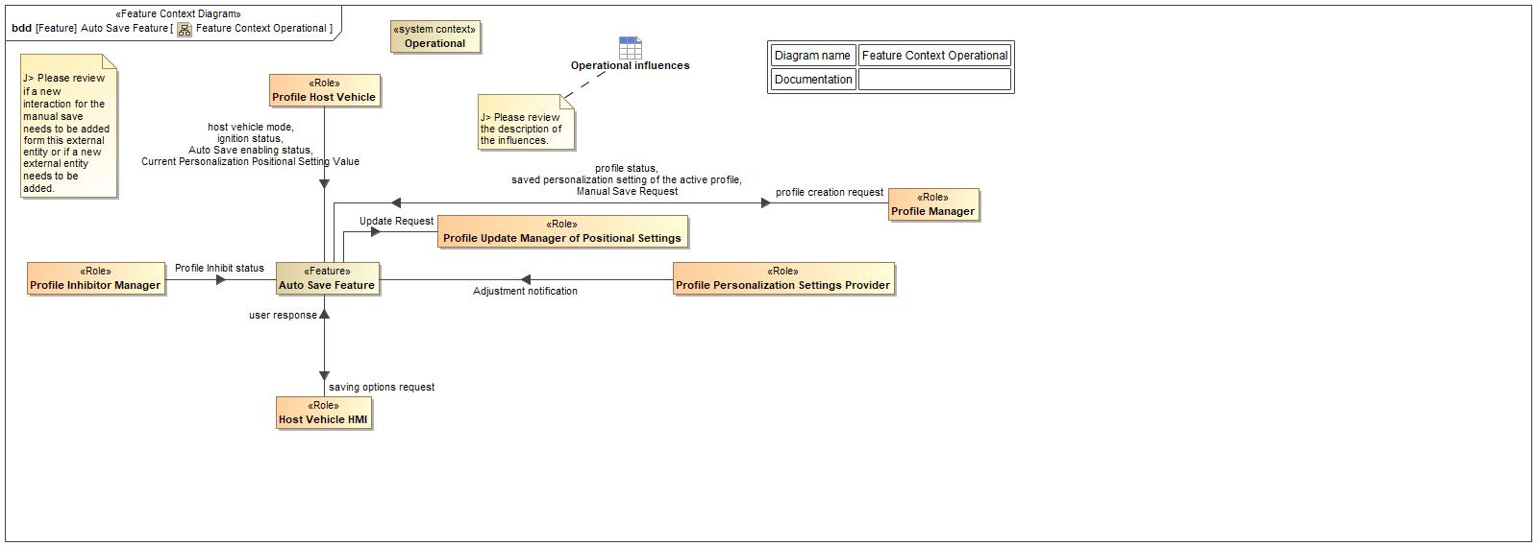

Figure 2: Feature Context Operational

## List of Influences

|  |  |  |
| --- | --- | --- |
| **ID** | **External Entity** | **Influence Description** |
| Adjustment notification | Profile Personalization Settings Provider To Auto Save Feature | This information item represents necessary to let the feature know that a positional adjustment is taking place. |
| Auto Save enabling status | Profile Host Vehicle To Auto Save Feature | This information item represents the information that is required to convey enable and disable status of the Auto Save feature. |
| Current Personalization Positional Setting Value | Profile Host Vehicle To Auto Save Feature | This information item represents the current values of the positional settings. Values like seat forward position, seat tilt incline, .. etc. |
| host vehicle mode | Profile Host Vehicle To Auto Save Feature | This information item represents the information necessary to convey the status of the profile host vehicle. |
| ignition status | Profile Host Vehicle To Auto Save Feature | This information item represents the ignition status of the profile host vehicle (On,OFF, Crank, ACC, ... etc.). |
| Manual Save Request | Profile Manager To Auto Save Feature | Represents the information necessary to indicate that a manual saves has ocurred related to active profile. |
| profile creation request | Auto Save Feature To Profile Manager | This information item represents the information that the Auto Save Feature will convey to present a request to create a new profile. |
| Profile Inhibit status | Profile Inhibitor Manager To Auto Save Feature | This information item represents the status of the profile inhibitor (Active, Not active, Error). |
| profile status | Profile Manager To Auto Save Feature | This information item represents the information necessary to convey that current status of the user personalization profile. |
| saved personalization setting of the active profile | Profile Manager To Auto Save Feature | This information item represents the information needed to convey the values of the settings saved on the current user active profile. |
| saving options request | Auto Save Feature To Host Vehicle HMI | This information item represents the information that the Auto save feature convey to request an external entity to present some saving options. |
| Update Request | Auto Save Feature To Profile Update Manager of Positional Settings | This information item represents the information that the Auto Save feature will convey to request an external entity to perform a save current position value action/activity |
| user response | Host Vehicle HMI To Auto Save Feature | This information item represents the information that was convey from the User to a request from the Auto Save Feature or the Vehicle. |

Table 7: List of Influences

# Feature Modeling

## Operation Modes and States

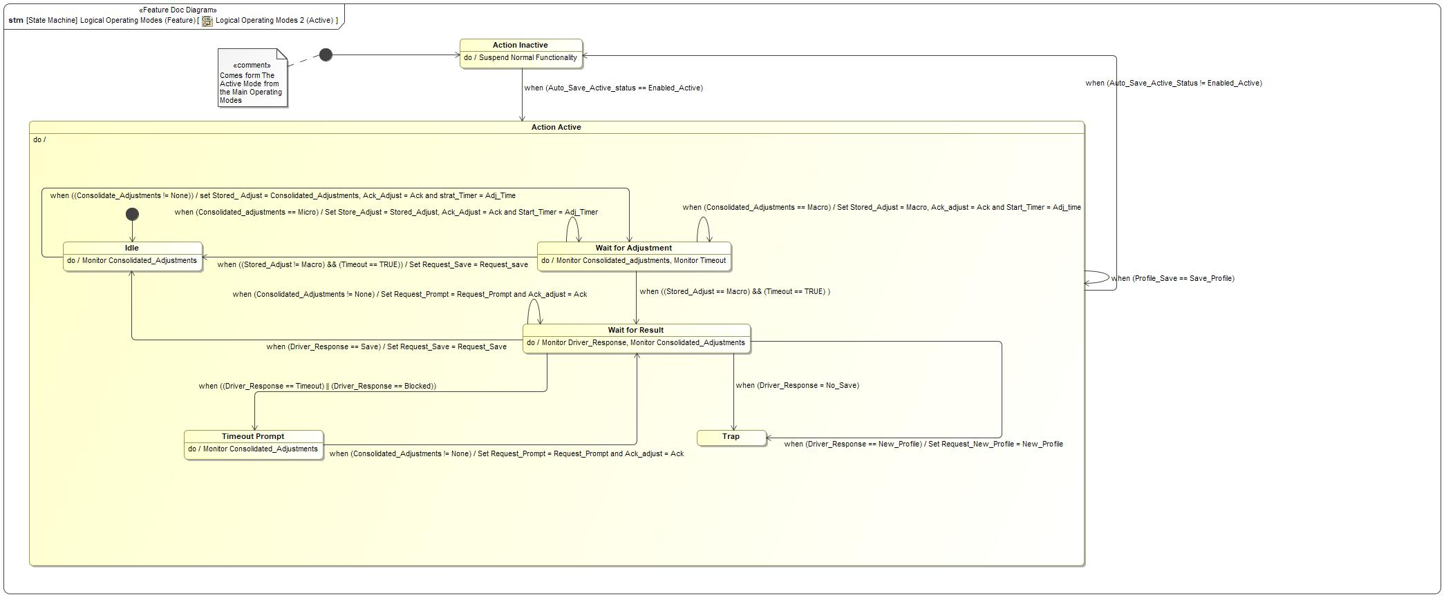

Figure 3: Logical Operating Modes 2 (Active)

|  |  |  |
| --- | --- | --- |
| **State** | **Description** | **Requirements Reference** (optional) |
| Action Active | The Auto Save feature enters the Action Active state when the Auto Save status is Enabled Active. The Auto Save feature will make saving decisions when in the Action Active state. |  |
| Action Inactive | The Auto Save feature enters the Action Inactive state when the status of Auto Save is no longer Enabled Active. The Auto Save feature will not make saving decisions when in the Action Inactive state. |  |
| Idle | The Idle sub-state checks for positional settings changes. If changes occur, it will transition to the Wait for Adjustment sub-state. |  |
| Timeout Prompt | The Timeout Prompt sub-state waits for another adjustment. This state is entered when the user ignores the prompt or the prompt is blocked. This state gives the user another chance to respond to the prompt. |  |
| Trap | When the user has indicated that they do not wish to retain positional changes, then the Auto Save system shall temporarily disable saving functionality by remaining in the Trap sub-state. While in the Trap sub-state, Auto Save will continue to process positional adjustments but will not decide on appropriate saving actions. Auto Save will remain in the Trap state until the status of Auto Save changes. |  |
| Wait for Adjustment | The Auto Save feature enters the Wait for Adjustment sub-state when it detects a positional adjustment. This sub-state allows the user to make additional positional setting changes to be included in the current processing of positional setting changes. When the user completes adjusting, then Auto Save will determine the appropriate saving action. |  |
| Wait for Result | The Wait for Result sub-state waits for feedback from the user. Additionally, the user can make additional positional setting changes to be included in the current processing of positional setting changes. When the feedback timer times out, or the user provides feedback, then Auto Save will determine which saving behavior to execute. |  |

Table 8: Operation Modes and States on Logical Operating Modes 2 (Active)

|  |  |  |  |  |
| --- | --- | --- | --- | --- |
| **Transition ID** | **Source** | **Destination** | **Description** | **Requirements Reference**  (optional) |
| T1 | Action Active | Action Active | Trigger: Profile_Save == Save_Profile  ChangeEvent when (Profile_Save == Save_Profile) |  |
| T2 | Wait for Adjustment | Idle | Trigger: (Stored_Adjust != Macro) && (Timeout == TRUE)  Effect: Set Request_Save = Request_save  ChangeEvent when ((Stored_Adjust != Macro) && (Timeout == TRUE)) |  |
| T3 | Wait for Result | Wait for Result | Trigger: Consolidated_Adjustments != None  Effect: Set Request_Prompt = Request_Prompt and Ack_adjust = Ack  ChangeEvent when (Consolidated_Adjustments != None) |  |
| T4 | Wait for Adjustment | Wait for Adjustment | Trigger: Consolidated_adjustments == Micro  Effect: Set Store_Adjust = Stored_Adjust, Ack_Adjust = Ack and Start_Timer = Adj_Timer  ChangeEvent when (Consolidated_adjustments == Micro) |  |
| T5 | Wait for Result | Trap | Trigger: Driver_Response = No_Save  ChangeEvent when (Driver_Response = No_Save) |  |
| T6 | Action Inactive | Action Active | Trigger: Auto_Save_Active_status == Enabled_Active  ChangeEvent when (Auto_Save_Active_status == Enabled_Active) |  |
| T7 | Wait for Adjustment | Wait for Adjustment | Trigger: Consolidated_Adjustments == Macro  Effect: Set Stored_Adjust = Macro, Ack_adjust = Ack and Start_Timer = Adj_time  ChangeEvent when (Consolidated_Adjustments == Macro) |  |
| T8 | Wait for Result | Timeout Prompt | Trigger: (Driver_Response == Timeout) || (Driver_Response == Blocked)  ChangeEvent when ((Driver_Response == Timeout) || (Driver_Response == Blocked)) |  |
| T9 | Wait for Result | Idle | Trigger: Driver_Response == Save  Effect: Set Request_Save = Request_Save  ChangeEvent when (Driver_Response == Save) |  |
| T10 | Wait for Adjustment | Wait for Result | Trigger: (Stored_Adjust == Macro) && (Timeout == TRUE)  ChangeEvent when ((Stored_Adjust == Macro) && (Timeout == TRUE) ) |  |
| T11 | Action Active | Action Inactive | Trigger: Auto_Save_Active_Status != Enabled_Active  ChangeEvent when (Auto_Save_Active_Status != Enabled_Active) |  |
| T12 | Idle | Wait for Adjustment | Name: (Consolidate_Adjustments != None)  Trigger: (Consolidate_Adjustments != None)  Effect: set Stored_ Adjust = Consolidated_Adjustments, Ack_Adjust = Ack and strat_Timer = Adj_Time  ChangeEvent when ((Consolidate_Adjustments != None)) |  |
| T13 | Wait for Result | Trap | Trigger: Driver_Response == New_Profile  Effect: Set Request_New_Profile = New_Profile  ChangeEvent when (Driver_Response == New_Profile) |  |
| T14 |  |  | Name: Overall Initial Node |  |
| T15 | Timeout Prompt | Wait for Result | Trigger: Consolidated_Adjustments != None  Effect: Set Request_Prompt = Request_Prompt and Ack_adjust = Ack  ChangeEvent when (Consolidated_Adjustments != None) |  |
| T16 |  |  | Name: initial node |  |

Table 9: Transitions between Operation Modes and States on Logical Operating Modes 2 (Active)

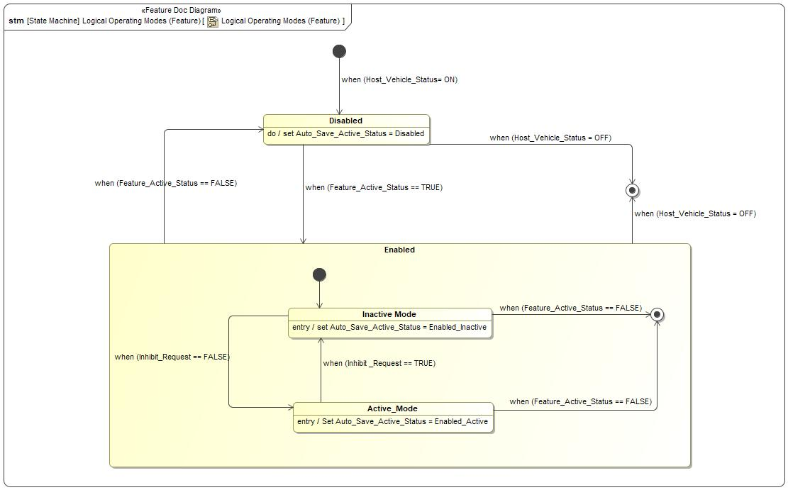

Figure 4: Logical Operating Modes (Feature)

|  |  |  |
| --- | --- | --- |
| **State** | **Description** | **Requirements Reference** (optional) |
| Active_Mode | The Auto Save feature enters the Active Mode sub-state when it determines that the current profile is in an appropriate state to have positional settings saved. This occurs when no Inhibit Requests are active. When in this sub-state, the Auto Save status will be Enabled Active.  Entry behavior: Set Auto_Save_Active_Status = Enabled_Active |  |
| Disabled | The Auto Save feature is in the Disabled state when the Feature Active conditions have been made false. When in this state, the Auto Save feature will suspend monitoring and deciding functionality. |  |
| Enabled | The Auto Save feature will enter the Enabled state when the Feature Active conditions are true. When in this state, the Auto Save feature will activate monitoring functionality. When in this state, the Auto Save feature will be in one of two sub-states, Inactive Mode and Active Mode. The Inhibit Request determines which of these two sub-states the Auto Save feature is in. |  |
| Inactive Mode | The Auto Save feature enters the Inactive Mode sub-state when it determines that the current profile is not in an appropriate state to have positional settings saved. This occurs when Inhibit Requests are active. When in this sub-state, the Auto Save status will be Enabled Inactive.  Entry behavior: set Auto_Save_Active_Status = Enabled_Inactive |  |

Table 10: Operation Modes and States on Logical Operating Modes (Feature)

|  |  |  |  |  |
| --- | --- | --- | --- | --- |
| **Transition ID** | **Source** | **Destination** | **Description** | **Requirements Reference**  (optional) |
| T1 | Enabled | Disabled | Trigger: Feature_Active_Status == FALSE  ChangeEvent when (Feature_Active_Status == FALSE) |  |
| T2 | Disabled | Enabled | Trigger: Feature_Active_Status == TRUE  ChangeEvent when (Feature_Active_Status == TRUE) |  |
| T3 | Active_Mode | Exit | Trigger: Feature_Active_Status == FALSE  ChangeEvent when (Feature_Active_Status == FALSE) |  |
| T4 |  |  | Name: Overall initial Node  Trigger: Host_Vehicle_Status = ON  ChangeEvent when (Host_Vehicle_Status= ON) |  |
| T5 | Disabled | Exit | Trigger: Host_Vehicle_Status = OFF  ChangeEvent when (Host_Vehicle_Status = OFF) |  |
| T6 |  |  | Name: initial node Enabled Mode |  |
| T7 | Inactive Mode | Active_Mode | Trigger: Inhibit_Request == FALSE  ChangeEvent when (Inhibit_Request == FALSE) |  |
| T8 | Active_Mode | Inactive Mode | Trigger: Inhibit _Request == TRUE  ChangeEvent when (Inhibit _Request == TRUE) |  |
| T9 | Enabled | Exit | Trigger: Host_Vehicle_Status = OFF  ChangeEvent when (Host_Vehicle_Status = OFF) |  |
| T10 | Inactive Mode | Exit | Trigger: Feature_Active_Status == FALSE  ChangeEvent when (Feature_Active_Status == FALSE) |  |

Table 11: Transitions between Operation Modes and States on Logical Operating Modes (Feature)

## Use Cases

### Use Case Diagram

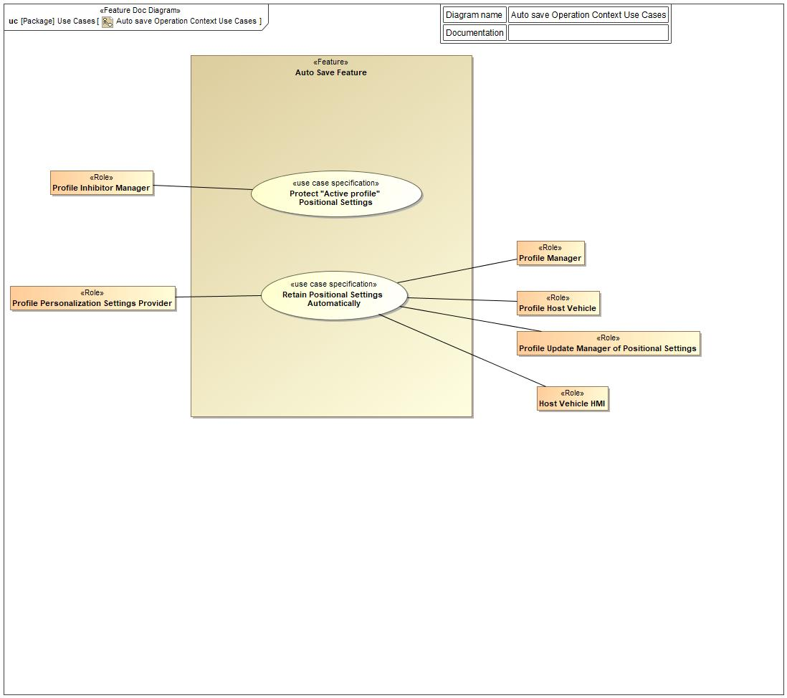

Figure 5: Auto save Operation Context Use Cases

### Actors

| **Actor** | **Description** |
| --- | --- |
| Host Vehicle HMI | The Host Vehicle HMI is a role from the personalization domain. It represents any of Human Machine Interfaces contained or used to interact between the profile user and the profile host vehicle. |
| Profile Host Vehicle | The Profile Host vehicle is a role from the personalization domain. It represents any vehicle that is hosting, using and consuming the information contain in the customer personalization profile. |
| Profile Inhibitor Manager | The Profile Inhibitor Manager is a role from the personalization domain. It represents any entity in the domain that has the capability to inhibit any functionality in the domain related to the profile customization/personalization and its change of value and status. |
| Profile Manager | The Profile Manager is a role from the personalization domain. It represents any entity that has the task of managing, controlling and administrating the user personalization profile. |
| Profile Personalization Settings Provider | The Profile personalization settings provider is a role from the personalization domain. It represents any entity in the domain that provides the profile and the profile manager with information about the current status/value of the settings. |
| Profile Update Manager of Positional Settings | The Profile Update Manager of positional Settings is a role from the personalization domain. It represents any entity in the domain that manage the update of any of the positional settings in the user profile. |

Table 12: List of Actors

### Use Case Descriptions

Retain Positional Settings Automatically

|  |  |  |
| --- | --- | --- |
| **Actors** | Primary | Profile Personalization Settings Provider |
| Secondary | Profile Update Manager of Positional Settings |
| Secondary | Profile Manager |
| Secondary | Profile Host Vehicle |
| Secondary | Host Vehicle HMI |
| **Subject** |  | Auto Save Feature |
| **Description** |  |  |
| **Preconditions** | PreC1 | Auto Save Feature is Enabled. |
| PreC2 | There is no Inhibit Request active on the host vehicle. |
| **Triggers** | T1 | Postional Adjustment Notification is Received. |
| **Main Flow Description** |  | The user will modify their positional settings and the Automatic Saving Feature (Auto Save) will assist them with retaining changes. |
| **Main Flow** | M1 | Adjustment of settings happens |
| M2 | Profile Personalization Settings Provider provides positional adjustment information to Automatic Saving Feature (Auto Save). |
| M3 | Automatic Saving Feature (Auto Save) decides the strategy to do based on the type of positional adjustment. |
| M4 | If the Automatic Saving Feature (Auto Save) determines that the user should be consulted about the appropriate action, the Automatic Saving Feature (Auto Save) will obtain feedback from the user (see Alternative Flow A1-4). |
| M5 | Automatic Saving Feature (Auto Save) sends save request to the Profile Update Manager of Positional Settings. |
| M6 | Profile Update Manager of Positional Settings saves vehicle positional settings. |
| M7 | Automatic Saving Feature (Auto Save) receives notification from Profile Update Manager of Positional Settings, indicating that positional settings have been retained. |
| M8 | Automatic Saving Feature (Auto Save) clears previous adjustment information. |
| **Alternative Flow Description** |  | The Automatic Saving Feature (Auto Save) will consult the user if it determines that the user should be consulted about the appropriate action. The following flow triggers at step M7 and returns to step M8: |
| **Alternative Flow Steps** | A1 | Automatic Saving Feature (Auto Save) sends a request for feedback to the Vehicle HMI. |
| A2 | Automatic Saving Feature (Auto Save) waits for the user’s feedback from the Vehicle HMI. |
| A3 | Automatic Saving Feature (Auto Save) receives the user’s feedback from the Vehicle HMI. |
| A4 | The user’s response was to retain positional settings. |
| **Exceptional Flow Description** |  | E1 - The user saves their positional settings independently of the Automatic Saving Feature (Auto Save). The following flow can trigger at any time during the main flow and ends on its own: |
| **Exceptional Flow Description** |  | E2 - The user’s response was to change the user profile. The following flow triggers at step A1M4 and ends on its own: |
| **Exceptional Flow Description** |  | E3 - The user’s response was not to retain positional settings or the user did not provide a response. The following flow triggers at step A1M4 and ends on its own: |
| **Exceptional Flow Steps** | E1 | E1M1.Automatic Saving Feature (Auto Save) receives notification from Profile Update Manager of Positional Settings, indicating that positional settings have been retained.  E1M2.Automatic Saving Feature (Auto Save) clears previous adjustment information. |
| E2 | E3M1. Automatic Saving Feature (Auto Save) clears previous adjustment information.  E3M2. Automatic Saving Feature (Auto Save) suspends the decide functionality. |
| E3 | E2M1. Automatic Saving Feature (Auto Save) sends profile change request to Profile Manager.  E2M2. Profile Manager changes user profile.  E2M3. Automatic Saving Feature (Auto Save) receives notification from Profile Manager, indicating that a profile change has been initiated.  E2M4. Automatic Saving Feature (Auto Save) clears previous adjustment information.  E2M5. Automatic Saving Feature (Auto Save) suspends the decide functionality. |
| **Postconditions** | PostC1 | Profile update Manager for positional settings updates the active profile. |
| PostC2 | The Auto Save Feature cleared any previous adjustment information. |

Protect "Active profile" Positional Settings

|  |  |  |
| --- | --- | --- |
| **Actors** | Primary | Profile Inhibitor Manager |
| Secondary |  |
| **Subject** |  | Auto Save Feature |
| **Description** |  |  |
| **Preconditions** | PreC1 | Auto Save feature is Enabled |
| PreC2 | There is no Inhibit Request active on the host vehicle. |
| **Triggers** | T1 | The Auto Save Feature receives the inhibit status equal to Active. |
| **Main Flow Description** |  | There are many conditions in which a user will not want their positional changes to be saved on the active profile in the host vehicle. When one of those conditions is detected by the inhibitor manager, it sends an Inhibit Request to the Auto Save feature. Then the Auto Save feature shall not assist the user with retaining their positional settings. |
| **Main Flow** | M1 | The Profile Inhibitor Manager sends inhibit status to Auto Save feature.. |
| M2 | The Auto Save Feature receives the inhibit status from the Profile Inhibitor Manager. |
| M3 | The Auto Save Feature validates the value of the inhibit request. |
| M4 | The Auto Save Feature deactivates the automatic retention of positional settings. |
| M5 | The Auto Save Feature keeps monitoring the inhibit status (receiving and validating) |
| M6 | if the inhibit status is "Inactive", the Auto Save Feature activates the automatic retention of positional settings |
| **Alternative Flow Description** |  | The Active profile remains inhibit. The Auto Save Feature monitors the status of the profile inhibit, validates that the profile inhibit status is still Active and The auto save function of automatic retain positional settings remains deactivated. |
| **Alternative Flow Steps** | A1 | If the inhibit status remains Active, the Auto Save Feature shall keep the automatic retention of positional settings deactivated. |
| A2 | The Auto Save Feature shall continue monitoring the inhibit status. |
| **Postconditions** | PostC1 | Auto Save continues to obey the inhibit request over key cycles. |
| PostC2 | Positional Settings on the active profile did not get changed during the time that the Inhibit Status was Active. |

## Driving and Operation Scenarios

## Decision Tables

*Not supported by MagicDraw report generation.*

# Feature Requirements

## Functional Requirements

F-ASMS-04 Auto Save Disable 1

When there is at least one Inhibit Request, the Auto Save Feature shall be in the "Inactive Mode" sub-state.

|  |  |  |  |  |  |  |  |
| --- | --- | --- | --- | --- | --- | --- | --- |
| Requirement ID: F-ASMS-04 | | | | | | | |
| **Rationale** | Determines Auto Save state when one or multiple Inhibit Request are present. | | | | | | |
| **Acceptance Criteria** |  | | | | | | |
| **Notes** |  | | | | | | |
| **Source** |  | | | | | **Owner** |  |
| **Source Req.** | * 1676569384.jpg STK_ASMS17 Auto Save Inhibit ON | | | | | **V&V Method** |  |
| **Type** |  | | | **Priority** |  | **Status** | Approved |
| [Req. Template](http://wiki.ford.com/display/RequirementsEngineering/Requirements+Attributes) Version | | 6.0 | End of Requirement | | | | |

F-ASMS-05 Auto Save Enable 1

When there is no active Inhibit Request, the Auto Save Feature shall be in the "Active Mode" sub-state.

|  |  |  |  |  |  |  |  |
| --- | --- | --- | --- | --- | --- | --- | --- |
| Requirement ID: F-ASMS-05 | | | | | | | |
| **Rationale** | Determines the state when no Inhibit Request is present. | | | | | | |
| **Acceptance Criteria** |  | | | | | | |
| **Notes** |  | | | | | | |
| **Source** |  | | | | | **Owner** |  |
| **Source Req.** | * 1676569384.jpg STK_ASMS18 Auto Save Inhibit OFF | | | | | **V&V Method** |  |
| **Type** |  | | | **Priority** |  | **Status** | Approved |
| [Req. Template](http://wiki.ford.com/display/RequirementsEngineering/Requirements+Attributes) Version | | 6.0 | End of Requirement | | | | |

F-ASMS-06 Vehicle 1

When at least one value of the Activation Preconditions for Auto Save is false, the Auto Save Feature shall be in the "Disabled" state.

|  |  |  |  |  |  |  |  |
| --- | --- | --- | --- | --- | --- | --- | --- |
| Requirement ID: F-ASMS-06 | | | | | | | |
| **Rationale** | Ensures that Auto Save turns off when the Activation Preconditions are not met. | | | | | | |
| **Acceptance Criteria** |  | | | | | | |
| **Notes** |  | | | | | | |
| **Source** |  | | | | | **Owner** |  |
| **Source Req.** | * 1676569384.jpg STK_ASMS12 Deactivate Feature | | | | | **V&V Method** |  |
| **Type** |  | | | **Priority** |  | **Status** | Approved |
| [Req. Template](http://wiki.ford.com/display/RequirementsEngineering/Requirements+Attributes) Version | | 6.0 | End of Requirement | | | | |

F-ASMS-07 Vehicle 2

When all the Activation Preconditions for Auto Save are true, the Auto Save Feature shall be in the "Enabled" state.

|  |  |  |  |  |  |  |  |
| --- | --- | --- | --- | --- | --- | --- | --- |
| Requirement ID: F-ASMS-07 | | | | | | | |
| **Rationale** | Ensures that Auto Save turns on when the Activation Preconditions are met. | | | | | | |
| **Acceptance Criteria** |  | | | | | | |
| **Notes** |  | | | | | | |
| **Source** |  | | | | | **Owner** |  |
| **Source Req.** | * 1676569384.jpg STK_ASMS13 Activate Feature | | | | | **V&V Method** |  |
| **Type** |  | | | **Priority** |  | **Status** | Approved |
| [Req. Template](http://wiki.ford.com/display/RequirementsEngineering/Requirements+Attributes) Version | | 6.0 | End of Requirement | | | | |

F-ASMS-14 Remember Changes 07

If the user's feedback was "Change Profile", the Auto Save Feature shall request that the Profile Settings Manager on the vehicle assist the user with changing the profile.

|  |  |  |  |  |  |  |  |
| --- | --- | --- | --- | --- | --- | --- | --- |
| Requirement ID: F-ASMS-14 | | | | | | | |
| **Rationale** | Ensures that Auto Save will request a change of Profile from Personal and Portable Profiles when the user responds to the prompt. | | | | | | |
| **Acceptance Criteria** |  | | | | | | |
| **Notes** |  | | | | | | |
| **Source** |  | | | | | **Owner** |  |
| **Source Req.** | * 1676569384.jpg STK_ASMS37 Suggest Profile Change | | | | | **V&V Method** |  |
| **Type** |  | | | **Priority** |  | **Status** | Approved |
| [Req. Template](http://wiki.ford.com/display/RequirementsEngineering/Requirements+Attributes) Version | | 6.0 | End of Requirement | | | | |

F-ASMS-20 Remember Changes 01

When the Auto Save Feature has ceased receiving new Position Adjustments from the Profile Personalization Settings Provider and all Position Adjustments do not deviate significantly from the saved position, the Auto Save Feature shall assist with retaining the current position.

|  |  |  |  |  |  |  |  |
| --- | --- | --- | --- | --- | --- | --- | --- |
| Requirement ID: F-ASMS-20 | | | | | | | |
| **Rationale** | Ensures that small, or micro, adjustments are saved immediately. | | | | | | |
| **Acceptance Criteria** |  | | | | | | |
| **Notes** |  | | | | | | |
| **Source** |  | | | | | **Owner** |  |
| **Source Req.** | * 1676569384.jpg STK_ASMS57 Classify Adjustment as Insignificant | | | | | **V&V Method** |  |
| **Type** |  | | | **Priority** |  | **Status** | Approved |
| [Req. Template](http://wiki.ford.com/display/RequirementsEngineering/Requirements+Attributes) Version | | 6.0 | End of Requirement | | | | |

F-ASMS-21 Remember Changes 02

When the Auto Save Feature has ceased receiving new Position Adjustments and at least one Position Adjustment deviates significantly from the saved position, the Auto Save Feature shall request Host Vehicle HMI to request feedback from the user regarding the save action.

|  |  |  |  |  |  |  |  |
| --- | --- | --- | --- | --- | --- | --- | --- |
| Requirement ID: F-ASMS-21 | | | | | | | |
| **Rationale** | Ensures that large, or macro, adjustments result in a prompt to the user. | | | | | | |
| **Acceptance Criteria** |  | | | | | | |
| **Notes** |  | | | | | | |
| **Source** |  | | | | | **Owner** |  |
| **Source Req.** | * 1676569384.jpg STK_ASMS58 Classify Adjustment as Significant | | | | | **V&V Method** |  |
| **Type** |  | | | **Priority** |  | **Status** | Approved |
| [Req. Template](http://wiki.ford.com/display/RequirementsEngineering/Requirements+Attributes) Version | | 6.0 | End of Requirement | | | | |

F-ASMS-22 Classify Adjustment 1

When the Auto Save Feature receives a Position Adjustment from the Profile Personalization Settings Provider while in the "Idle" action state, it shall wait for more Position Adjustments from the Profile Personalization Settings Provider before retaining adjustments or requesting feedback from the user.

|  |  |  |  |  |  |  |  |
| --- | --- | --- | --- | --- | --- | --- | --- |
| Requirement ID: F-ASMS-22 | | | | | | | |
| **Rationale** | Ensures that Auto Save will wait for more adjustments before activating a retention action. | | | | | | |
| **Acceptance Criteria** |  | | | | | | |
| **Notes** |  | | | | | | |
| **Source** |  | | | | | **Owner** |  |
| **Source Req.** | * 1676569384.jpg STK_ASMS38 Minimal Prompts * 1676569384.jpg STK_ASMS55 Capturing Multiple Positional Adjustments | | | | | **V&V Method** |  |
| **Type** |  | | | **Priority** |  | **Status** | Approved |
| [Req. Template](http://wiki.ford.com/display/RequirementsEngineering/Requirements+Attributes) Version | | 6.0 | End of Requirement | | | | |

F-ASMS-24 Save Position 5: Auto Save Domain

If the vehicle has the capability to adjust and retain a setting of a commodity in the Auto Save Domain, the Auto Save shall implement a mechanism to aid the user with retaining their preferred setting.

|  |  |  |  |  |  |  |  |
| --- | --- | --- | --- | --- | --- | --- | --- |
| Requirement ID: F-ASMS-24 | | | | | | | |
| **Rationale** | Ensures that Auto Save is limited to the settings in the Auto Save Domain. | | | | | | |
| **Acceptance Criteria** |  | | | | | | |
| **Notes** |  | | | | | | |
| **Source** |  | | | | | **Owner** |  |
| **Source Req.** | * 1676569384.jpg STK_ASMS61 Save Seat Positions * 1676569384.jpg STK_ASMS62 Save Mirror Positions * 1676569384.jpg STK_ASMS63 Save AHUD Positions * 1676569384.jpg STK_ASMS67 Save Optional Positions | | | | | **V&V Method** |  |
| **Type** |  | | | **Priority** |  | **Status** | Approved |
| [Req. Template](http://wiki.ford.com/display/RequirementsEngineering/Requirements+Attributes) Version | | 6.0 | End of Requirement | | | | |

F-ASMS-30 Auto Save Disable 2

When the Auto Save Feature is not in the "Active Mode" sub-state, it shall avoid requesting feedback from the user.

|  |  |  |  |  |  |  |  |
| --- | --- | --- | --- | --- | --- | --- | --- |
| Requirement ID: F-ASMS-30 | | | | | | | |
| **Rationale** | Determines Auto Save feedback behavior when one or multiple Inhibit Request are present. | | | | | | |
| **Acceptance Criteria** |  | | | | | | |
| **Notes** |  | | | | | | |
| **Source** |  | | | | | **Owner** |  |
| **Source Req.** | * 1676569384.jpg STK_ASMS12 Deactivate Feature * 1676569384.jpg STK_ASMS17 Auto Save Inhibit ON | | | | | **V&V Method** |  |
| **Type** |  | | | **Priority** |  | **Status** | Approved |
| [Req. Template](http://wiki.ford.com/display/RequirementsEngineering/Requirements+Attributes) Version | | 6.0 | End of Requirement | | | | |

F-ASMS-31 Auto Save Disable 3

When the Auto Save Feature is not in the "Active Mode" sub-state, it shall avoid requesting the change of profile.

|  |  |  |  |  |  |  |  |
| --- | --- | --- | --- | --- | --- | --- | --- |
| Requirement ID: F-ASMS-31 | | | | | | | |
| **Rationale** | Determines Auto Save profile change behavior when one or multiple Inhibit Request are present. | | | | | | |
| **Acceptance Criteria** |  | | | | | | |
| **Notes** |  | | | | | | |
| **Source** |  | | | | | **Owner** |  |
| **Source Req.** | * 1676569384.jpg STK_ASMS12 Deactivate Feature * 1676569384.jpg STK_ASMS17 Auto Save Inhibit ON | | | | | **V&V Method** |  |
| **Type** |  | | | **Priority** |  | **Status** | Approved |
| [Req. Template](http://wiki.ford.com/display/RequirementsEngineering/Requirements+Attributes) Version | | 6.0 | End of Requirement | | | | |

F-ASMS-32 Auto Save Enable 2

When the Auto Save Feature is in the "Active Mode" sub-state, it shall have the ability to request the saving of positional settings.

|  |  |  |  |  |  |  |  |
| --- | --- | --- | --- | --- | --- | --- | --- |
| Requirement ID: F-ASMS-32 | | | | | | | |
| **Rationale** | Determines the retention behavior when no Inhibit Request is present. | | | | | | |
| **Acceptance Criteria** |  | | | | | | |
| **Notes** |  | | | | | | |
| **Source** |  | | | | | **Owner** |  |
| **Source Req.** | * 1676569384.jpg STK_ASMS13 Activate Feature * 1676569384.jpg STK_ASMS18 Auto Save Inhibit OFF * 1676569384.jpg STK_ASMS61 Save Seat Positions * 1676569384.jpg STK_ASMS62 Save Mirror Positions * 1676569384.jpg STK_ASMS63 Save AHUD Positions * 1676569384.jpg STK_ASMS67 Save Optional Positions | | | | | **V&V Method** |  |
| **Type** |  | | | **Priority** |  | **Status** | Approved |
| [Req. Template](http://wiki.ford.com/display/RequirementsEngineering/Requirements+Attributes) Version | | 6.0 | End of Requirement | | | | |

F-ASMS-33 Auto Save Enable 3

When the Auto Save Feature is in the "Active Mode" sub-state, it shall have the ability to request feedback from the user.

|  |  |  |  |  |  |  |  |
| --- | --- | --- | --- | --- | --- | --- | --- |
| Requirement ID: F-ASMS-33 | | | | | | | |
| **Rationale** | Determines the feedback behavior when no Inhibit Request is present. | | | | | | |
| **Acceptance Criteria** |  | | | | | | |
| **Notes** |  | | | | | | |
| **Source** |  | | | | | **Owner** |  |
| **Source Req.** | * 1676569384.jpg STK_ASMS13 Activate Feature * 1676569384.jpg STK_ASMS18 Auto Save Inhibit OFF * 1676569384.jpg STK_ASMS58 Classify Adjustment as Significant | | | | | **V&V Method** |  |
| **Type** |  | | | **Priority** |  | **Status** | Approved |
| [Req. Template](http://wiki.ford.com/display/RequirementsEngineering/Requirements+Attributes) Version | | 6.0 | End of Requirement | | | | |

F-ASMS-34 Auto Save Enable 4

When the Auto Save Feature is in the "Active Mode" sub-state, it shall have the ability to request the change of active profile.

|  |  |  |  |  |  |  |  |
| --- | --- | --- | --- | --- | --- | --- | --- |
| Requirement ID: F-ASMS-34 | | | | | | | |
| **Rationale** | Determines the retention behavior when no Inhibit Request is present. | | | | | | |
| **Acceptance Criteria** |  | | | | | | |
| **Notes** |  | | | | | | |
| **Source** |  | | | | | **Owner** |  |
| **Source Req.** | * 1676569384.jpg STK_ASMS13 Activate Feature * 1676569384.jpg STK_ASMS18 Auto Save Inhibit OFF * 1676569384.jpg STK_ASMS37 Suggest Profile Change | | | | | **V&V Method** |  |
| **Type** |  | | | **Priority** |  | **Status** | Approved |
| [Req. Template](http://wiki.ford.com/display/RequirementsEngineering/Requirements+Attributes) Version | | 6.0 | End of Requirement | | | | |

F-ASMS-37 Classify Adjustment 4

After the Auto Save Feature has requested that the vehicle retain the current position, the Feature shall wait for further Position Adjustments from the Profile Personalization Settings Provider in the "Idle" action state.

|  |  |  |  |  |  |  |  |
| --- | --- | --- | --- | --- | --- | --- | --- |
| Requirement ID: F-ASMS-37 | | | | | | | |
| **Rationale** | Ensures that the Auto Save Feature is capable of retaining more new adjustments when it completes saving other position adjustments. | | | | | | |
| **Acceptance Criteria** |  | | | | | | |
| **Notes** |  | | | | | | |
| **Source** |  | | | | | **Owner** |  |
| **Source Req.** | * 1676569384.jpg STK_ASMS57 Classify Adjustment as Insignificant * 1676569384.jpg STK_ASMS58 Classify Adjustment as Significant | | | | | **V&V Method** |  |
| **Type** |  | | | **Priority** |  | **Status** | Approved |
| [Req. Template](http://wiki.ford.com/display/RequirementsEngineering/Requirements+Attributes) Version | | 6.0 | End of Requirement | | | | |

F-ASMS-38 Classify Adjustment 5

When the Auto Save Feature is in the "Active Mode" sub-state, it shall monitor adjustments and decide on saving actions.

|  |  |  |  |  |  |  |  |
| --- | --- | --- | --- | --- | --- | --- | --- |
| Requirement ID: F-ASMS-38 | | | | | | | |
| **Rationale** | Ensures that when Auto Save is activated, it will execute all of its functionality. | | | | | | |
| **Acceptance Criteria** |  | | | | | | |
| **Notes** |  | | | | | | |
| **Source** |  | | | | | **Owner** |  |
| **Source Req.** | * 1676569384.jpg STK_ASMS13 Activate Feature * 1676569384.jpg STK_ASMS18 Auto Save Inhibit OFF * 1676569384.jpg STK_ASMS61 Save Seat Positions * 1676569384.jpg STK_ASMS62 Save Mirror Positions * 1676569384.jpg STK_ASMS63 Save AHUD Positions * 1676569384.jpg STK_ASMS67 Save Optional Positions | | | | | **V&V Method** |  |
| **Type** |  | | | **Priority** |  | **Status** | Approved |
| [Req. Template](http://wiki.ford.com/display/RequirementsEngineering/Requirements+Attributes) Version | | 6.0 | End of Requirement | | | | |

F-ASMS-39 Classify Adjustment 6

When the Auto Save Feature has ceased receiving new Position Adjustments from the Profile Personalization Settings Provider, the Feature shall determine from the Position Adjustments whether it should save the current position or request feedback from the user.

|  |  |  |  |  |  |  |  |
| --- | --- | --- | --- | --- | --- | --- | --- |
| Requirement ID: F-ASMS-39 | | | | | | | |
| **Rationale** | Ensures that Auto Save will wait for all the user's position adjustments before saving or prompting the user. | | | | | | |
| **Acceptance Criteria** |  | | | | | | |
| **Notes** |  | | | | | | |
| **Source** |  | | | | | **Owner** |  |
| **Source Req.** | * 1676569384.jpg STK_ASMS57 Classify Adjustment as Insignificant * 1676569384.jpg STK_ASMS58 Classify Adjustment as Significant | | | | | **V&V Method** |  |
| **Type** |  | | | **Priority** |  | **Status** | Approved |
| [Req. Template](http://wiki.ford.com/display/RequirementsEngineering/Requirements+Attributes) Version | | 6.0 | End of Requirement | | | | |

F-ASMS-45 Classify Adjustment 7

The Auto Save Feature shall only process Positional Adjustments originating from the Auto Save Domain.

|  |  |  |  |  |  |  |  |
| --- | --- | --- | --- | --- | --- | --- | --- |
| Requirement ID: F-ASMS-45 | | | | | | | |
| **Rationale** | Ensures that Auto Save is confined to processing adjustments from the Auto Save Domain. | | | | | | |
| **Acceptance Criteria** |  | | | | | | |
| **Notes** |  | | | | | | |
| **Source** |  | | | | | **Owner** |  |
| **Source Req.** | * 1676569384.jpg STK_ASMS61 Save Seat Positions * 1676569384.jpg STK_ASMS62 Save Mirror Positions * 1676569384.jpg STK_ASMS63 Save AHUD Positions * 1676569384.jpg STK_ASMS67 Save Optional Positions | | | | | **V&V Method** |  |
| **Type** |  | | | **Priority** |  | **Status** | Approved |
| [Req. Template](http://wiki.ford.com/display/RequirementsEngineering/Requirements+Attributes) Version | | 6.0 | End of Requirement | | | | |

F-ASMS-46 Resume Classifying

When the Auto Save Feature has ceased classifying Position Adjustments and the User manually saves positional settings on the active User Profile, then the Auto Save Feature shall return to the "Idle" action state.

|  |  |  |  |  |  |  |  |
| --- | --- | --- | --- | --- | --- | --- | --- |
| Requirement ID: F-ASMS-46 | | | | | | | |
| **Rationale** | Ensures that Auto Save returns to an idle state when the user manually saves positions. | | | | | | |
| **Acceptance Criteria** |  | | | | | | |
| **Notes** |  | | | | | | |
| **Source** |  | | | | | **Owner** |  |
| **Source Req.** |  | | | | | **V&V Method** |  |
| **Type** |  | | | **Priority** |  | **Status** | Ready for Review |
| [Req. Template](http://wiki.ford.com/display/RequirementsEngineering/Requirements+Attributes) Version | | 6.0 | End of Requirement | | | | |

F-ASMS-47 Classify Adjustment 8

When the Auto Save Feature receives a Position Adjustment it shall compare it to the saved position setting in the profile.

|  |  |  |  |  |  |  |  |
| --- | --- | --- | --- | --- | --- | --- | --- |
| Requirement ID: F-ASMS-47 | | | | | | | |
| **Rationale** | Ensures that Auto Save will determine its saving action by comparing settings to their saved values. | | | | | | |
| **Acceptance Criteria** |  | | | | | | |
| **Notes** |  | | | | | | |
| **Source** |  | | | | | **Owner** |  |
| **Source Req.** | * 1676569384.jpg STK_ASMS57 Classify Adjustment as Insignificant * 1676569384.jpg STK_ASMS58 Classify Adjustment as Significant | | | | | **V&V Method** |  |
| **Type** |  | | | **Priority** |  | **Status** | Approved |
| [Req. Template](http://wiki.ford.com/display/RequirementsEngineering/Requirements+Attributes) Version | | 6.0 | End of Requirement | | | | |

F-ASMS-48 Classify Adjustment 2

The Auto Save feature shall clear position adjustment information when it has saved the current position, requested feedback from the user, or when the user has manually saved settings on the active User Profile.

|  |  |  |  |  |  |  |  |
| --- | --- | --- | --- | --- | --- | --- | --- |
| Requirement ID: F-ASMS-48 | | | | | | | |
| **Rationale** | Ensures that the Auto Save Feature clears position adjustment information when the data is no longer relevant. | | | | | | |
| **Acceptance Criteria** |  | | | | | | |
| **Notes** |  | | | | | | |
| **Source** |  | | | | | **Owner** |  |
| **Source Req.** |  | | | | | **V&V Method** |  |
| **Type** |  | | | **Priority** |  | **Status** | Ready for Review |
| [Req. Template](http://wiki.ford.com/display/RequirementsEngineering/Requirements+Attributes) Version | | 6.0 | End of Requirement | | | | |

F-ASMS-52 Remember Changes 08

If the user's feedback indicated that they wish to change the profile, the Auto Save Feature shall cease Processing Adjustments.

|  |  |  |  |  |  |  |  |
| --- | --- | --- | --- | --- | --- | --- | --- |
| Requirement ID: F-ASMS-52 | | | | | | | |
| **Rationale** | Ensures that Auto Save will cease operation until the user has changed their profile. | | | | | | |
| **Acceptance Criteria** |  | | | | | | |
| **Notes** |  | | | | | | |
| **Source** |  | | | | | **Owner** |  |
| **Source Req.** | * 1676569384.jpg STK_ASMS37 Suggest Profile Change | | | | | **V&V Method** |  |
| **Type** |  | | | **Priority** |  | **Status** | Approved |
| [Req. Template](http://wiki.ford.com/display/RequirementsEngineering/Requirements+Attributes) Version | | 6.0 | End of Requirement | | | | |

F-ASMS-53 Remember Changes 09

If the user's feedback indicated that they wish to retain the current position, the Auto Save Feature shall assist with retaining the current position.

|  |  |  |  |  |  |  |  |
| --- | --- | --- | --- | --- | --- | --- | --- |
| Requirement ID: F-ASMS-53 | | | | | | | |
| **Rationale** | Ensures that Auto Save will retain the current position when the user requests that it do so. | | | | | | |
| **Acceptance Criteria** |  | | | | | | |
| **Notes** |  | | | | | | |
| **Source** |  | | | | | **Owner** |  |
| **Source Req.** | * 1676569384.jpg STK_ASMS61 Save Seat Positions * 1676569384.jpg STK_ASMS62 Save Mirror Positions * 1676569384.jpg STK_ASMS63 Save AHUD Positions * 1676569384.jpg STK_ASMS67 Save Optional Positions | | | | | **V&V Method** |  |
| **Type** |  | | | **Priority** |  | **Status** | Approved |
| [Req. Template](http://wiki.ford.com/display/RequirementsEngineering/Requirements+Attributes) Version | | 6.0 | End of Requirement | | | | |

F-ASMS-54 Remember Changes 10

If the user's feedback indicated that they do not wish to retain the current position, the Auto Save Feature shall cease processing Position Adjustments.

|  |  |  |  |  |  |  |  |
| --- | --- | --- | --- | --- | --- | --- | --- |
| Requirement ID: F-ASMS-54 | | | | | | | |
| **Rationale** | Ensures that Auto Save ceases activity when the user indicates that they do not wish to save more adjustments. | | | | | | |
| **Acceptance Criteria** |  | | | | | | |
| **Notes** |  | | | | | | |
| **Source** |  | | | | | **Owner** |  |
| **Source Req.** | * 1676569384.jpg STK_ASMS53 Disregard Undesired Changes | | | | | **V&V Method** |  |
| **Type** |  | | | **Priority** |  | **Status** | Approved |
| [Req. Template](http://wiki.ford.com/display/RequirementsEngineering/Requirements+Attributes) Version | | 6.0 | End of Requirement | | | | |

F-ASMS-55 Save Position 1

If the profile has a setting related to an adjustable position, then the Auto Save Feature shall implement a mechanism determining when to request saving that position.

|  |  |  |  |  |  |  |  |
| --- | --- | --- | --- | --- | --- | --- | --- |
| Requirement ID: F-ASMS-55 | | | | | | | |
| **Rationale** | Ensures that Auto Save can take action when the user makes an adjustment. | | | | | | |
| **Acceptance Criteria** |  | | | | | | |
| **Notes** |  | | | | | | |
| **Source** |  | | | | | **Owner** |  |
| **Source Req.** | * 1676569384.jpg STK_ASMS61 Save Seat Positions * 1676569384.jpg STK_ASMS62 Save Mirror Positions * 1676569384.jpg STK_ASMS63 Save AHUD Positions * 1676569384.jpg STK_ASMS67 Save Optional Positions | | | | | **V&V Method** |  |
| **Type** |  | | | **Priority** |  | **Status** | Approved |
| [Req. Template](http://wiki.ford.com/display/RequirementsEngineering/Requirements+Attributes) Version | | 6.0 | End of Requirement | | | | |

F-ASMS-56 Save Position 2

If the profile has a setting related to an adjustable position, then the Auto Save Feature shall implement a mechanism to receive the adjustment of that position.

|  |  |  |  |  |  |  |  |
| --- | --- | --- | --- | --- | --- | --- | --- |
| Requirement ID: F-ASMS-56 | | | | | | | |
| **Rationale** | Ensures that Auto Save can receive a user's adjustment of a position. | | | | | | |
| **Acceptance Criteria** |  | | | | | | |
| **Notes** |  | | | | | | |
| **Source** |  | | | | | **Owner** |  |
| **Source Req.** | * 1676569384.jpg STK_ASMS61 Save Seat Positions * 1676569384.jpg STK_ASMS62 Save Mirror Positions * 1676569384.jpg STK_ASMS63 Save AHUD Positions * 1676569384.jpg STK_ASMS67 Save Optional Positions | | | | | **V&V Method** |  |
| **Type** |  | | | **Priority** |  | **Status** | Approved |
| [Req. Template](http://wiki.ford.com/display/RequirementsEngineering/Requirements+Attributes) Version | | 6.0 | End of Requirement | | | | |

F-ASMS-57 Save Position 3

If the profile has a setting related to an adjustable position, then the Automatic Saving Feature (Auto Save) shall implement a mechanism to request the saving of the current position.

|  |  |  |  |  |  |  |  |
| --- | --- | --- | --- | --- | --- | --- | --- |
| Requirement ID: F-ASMS-57 | | | | | | | |
| **Rationale** | Ensures that Auto Save can save changes to adjustable positions. | | | | | | |
| **Acceptance Criteria** |  | | | | | | |
| **Notes** |  | | | | | | |
| **Source** |  | | | | | **Owner** |  |
| **Source Req.** | * 1676569384.jpg STK_ASMS61 Save Seat Positions * 1676569384.jpg STK_ASMS62 Save Mirror Positions * 1676569384.jpg STK_ASMS63 Save AHUD Positions * 1676569384.jpg STK_ASMS67 Save Optional Positions | | | | | **V&V Method** |  |
| **Type** |  | | | **Priority** |  | **Status** | Approved |
| [Req. Template](http://wiki.ford.com/display/RequirementsEngineering/Requirements+Attributes) Version | | 6.0 | End of Requirement | | | | |

F-ASMS-58 Save Position 4

If the profile has a setting related to an adjustable position, then the Automatic Saving Feature (Auto Save) shall implement a mechanism to classify the position.

|  |  |  |  |  |  |  |  |
| --- | --- | --- | --- | --- | --- | --- | --- |
| Requirement ID: F-ASMS-58 | | | | | | | |
| **Rationale** | Ensures that Auto Save has the capability to classify position adjustments. | | | | | | |
| **Acceptance Criteria** |  | | | | | | |
| **Notes** |  | | | | | | |
| **Source** |  | | | | | **Owner** |  |
| **Source Req.** | * 1676569384.jpg STK_ASMS57 Classify Adjustment as Insignificant * 1676569384.jpg STK_ASMS58 Classify Adjustment as Significant * 1676569384.jpg STK_ASMS61 Save Seat Positions * 1676569384.jpg STK_ASMS62 Save Mirror Positions * 1676569384.jpg STK_ASMS63 Save AHUD Positions * 1676569384.jpg STK_ASMS67 Save Optional Positions | | | | | **V&V Method** |  |
| **Type** |  | | | **Priority** |  | **Status** | Approved |
| [Req. Template](http://wiki.ford.com/display/RequirementsEngineering/Requirements+Attributes) Version | | 6.0 | End of Requirement | | | | |

F-ASMS-62 Simple UI 06: Enabled Visible Settings

When the Auto Save Feature is in the "Enabled" state, then the Auto Save settings shall be visible to the user.

|  |  |  |  |  |  |  |  |
| --- | --- | --- | --- | --- | --- | --- | --- |
| Requirement ID: F-ASMS-62 | | | | | | | |
| **Rationale** | Ensures that the user can see the settings for Auto Save when the feature is enabled. | | | | | | |
| **Acceptance Criteria** |  | | | | | | |
| **Notes** |  | | | | | | |
| **Source** |  | | | | | **Owner** |  |
| **Source Req.** | * 1676569384.jpg STK_ASMS34 Settings Easy to Access 1 | | | | | **V&V Method** |  |
| **Type** |  | | | **Priority** |  | **Status** | Ready for Review |
| [Req. Template](http://wiki.ford.com/display/RequirementsEngineering/Requirements+Attributes) Version | | 6.0 | End of Requirement | | | | |

F-ASMS-64 Simple UI 09: Enabled Modifiable Settings

When the Auto Save Feature is in the "Enabled" state, then the Auto Save settings shall be modifiable by the user on the vehicle.

|  |  |  |  |  |  |  |  |
| --- | --- | --- | --- | --- | --- | --- | --- |
| Requirement ID: F-ASMS-64 | | | | | | | |
| **Rationale** | Ensures that the user can turn Auto Save on or off when the feature is enabled. | | | | | | |
| **Acceptance Criteria** |  | | | | | | |
| **Notes** |  | | | | | | |
| **Source** |  | | | | | **Owner** |  |
| **Source Req.** | * 1676569384.jpg STK_ASMS12 Deactivate Feature * 1676569384.jpg STK_ASMS13 Activate Feature * 1676569384.jpg STK_ASMS34 Settings Easy to Access 1 | | | | | **V&V Method** |  |
| **Type** |  | | | **Priority** | 1 - High | **Status** | Ready for Review |
| [Req. Template](http://wiki.ford.com/display/RequirementsEngineering/Requirements+Attributes) Version | | 6.0 | End of Requirement | | | | |

F-ASMS-65 Auto Save Disable 4

When the Auto Save Feature is not in the "Active Mode" sub-state, it shall avoid requesting retention of position.

|  |  |  |  |  |  |  |  |
| --- | --- | --- | --- | --- | --- | --- | --- |
| Requirement ID: F-ASMS-65 | | | | | | | |
| **Rationale** | Determines Auto Save saving behavior when one or multiple Inhibit Request are present. | | | | | | |
| **Acceptance Criteria** |  | | | | | | |
| **Notes** |  | | | | | | |
| **Source** |  | | | | | **Owner** |  |
| **Source Req.** | * 1676569384.jpg STK_ASMS12 Deactivate Feature * 1676569384.jpg STK_ASMS17 Auto Save Inhibit ON | | | | | **V&V Method** |  |
| **Type** |  | | | **Priority** |  | **Status** | Approved |
| [Req. Template](http://wiki.ford.com/display/RequirementsEngineering/Requirements+Attributes) Version | | 6.0 | End of Requirement | | | | |

F-ASMS-68 Simple UI 02: Disabled Invisible Settings

When the Auto Save Feature is in the "Disabled" state, then the Auto Save settings shall be invisible to the user.

|  |  |  |  |  |  |  |  |
| --- | --- | --- | --- | --- | --- | --- | --- |
| Requirement ID: F-ASMS-68 | | | | | | | |
| **Rationale** | Ensures that the user cannot see the settings for Auto Save when the feature is disabled. | | | | | | |
| **Acceptance Criteria** |  | | | | | | |
| **Notes** |  | | | | | | |
| **Source** |  | | | | | **Owner** |  |
| **Source Req.** | * 1676569384.jpg STK_ASMS12 Deactivate Feature * 1676569384.jpg STK_ASMS34 Settings Easy to Access 1 | | | | | **V&V Method** |  |
| **Type** |  | | | **Priority** |  | **Status** | Ready for Review |
| [Req. Template](http://wiki.ford.com/display/RequirementsEngineering/Requirements+Attributes) Version | | 6.0 | End of Requirement | | | | |

F-ASMS-69 Simple UI 03: Disabled Unchangeable Settings

When the Auto Save Feature is in the "Disabled" state, then the Auto Save settings shall be unchangeable by the user on the vehicle.

|  |  |  |  |  |  |  |  |
| --- | --- | --- | --- | --- | --- | --- | --- |
| Requirement ID: F-ASMS-69 | | | | | | | |
| **Rationale** | Ensures that the user cannot turn Auto Save on or off when the feature is disabled. | | | | | | |
| **Acceptance Criteria** |  | | | | | | |
| **Notes** |  | | | | | | |
| **Source** |  | | | | | **Owner** |  |
| **Source Req.** | * 1676569384.jpg STK_ASMS12 Deactivate Feature * 1676569384.jpg STK_ASMS34 Settings Easy to Access 1 | | | | | **V&V Method** |  |
| **Type** |  | | | **Priority** |  | **Status** | Ready for Review |
| [Req. Template](http://wiki.ford.com/display/RequirementsEngineering/Requirements+Attributes) Version | | 6.0 | End of Requirement | | | | |

### Error Handling

F-ASMS-09 Simple UI 01: Driver Distraction

When requesting feedback from the user regarding saving options, the Automatic Saving Feature (Auto Save) shall limit the length of the message to comply with driver distraction guidelines.

|  |  |  |  |  |  |  |  |
| --- | --- | --- | --- | --- | --- | --- | --- |
| Requirement ID: F-ASMS-09 | | | | | | | |
| **Rationale** | Ensures that we meet driver distraction requirements. | | | | | | |
| **Acceptance Criteria** |  | | | | | | |
| **Notes** |  | | | | | | |
| **Source** |  | | | | | **Owner** |  |
| **Source Req.** |  | | | | | **V&V Method** |  |
| **Type** |  | | | **Priority** |  | **Status** | Ready for Review |
| [Req. Template](http://wiki.ford.com/display/RequirementsEngineering/Requirements+Attributes) Version | | 6.0 | End of Requirement | | | | |

F-ASMS-51 Remember Changes 06

The Auto Save Feature shall extend the waiting time for feedback to the user by "Prompt Time Constant" if additional Positional Adjustments arrive from the Profile Personalization Settings Provider.

|  |  |  |  |  |  |  |  |
| --- | --- | --- | --- | --- | --- | --- | --- |
| Requirement ID: F-ASMS-51 | | | | | | | |
| **Rationale** | Ensures that the user has more time to respond to the prompt if they continue to make adjustments to position. | | | | | | |
| **Acceptance Criteria** |  | | | | | | |
| **Notes** |  | | | | | | |
| **Source** |  | | | | | **Owner** |  |
| **Source Req.** | * 1676569384.jpg STK_ASMS38 Minimal Prompts * 1676569384.jpg STK_ASMS64 Minimize Save Events | | | | | **V&V Method** |  |
| **Type** |  | | | **Priority** |  | **Status** | Approved |
| [Req. Template](http://wiki.ford.com/display/RequirementsEngineering/Requirements+Attributes) Version | | 6.0 | End of Requirement | | | | |

## Non-Functional Requirements

### Safety

*Not supported by MagicDraw report generation.*

### Security

No Security Requirements specified.

### Reliability

F-ASMS-27 Minimizing Saving Events 1

The Auto Save Feature shall minimize the number of times the current position is saved during a drive cycle to reduce degradation of vehicle memory.

|  |  |  |  |  |  |  |  |
| --- | --- | --- | --- | --- | --- | --- | --- |
| Requirement ID: F-ASMS-27 | | | | | | | |
| **Rationale** | Ensures that the Auto Save feature does not engage in too many save actions. | | | | | | |
| **Acceptance Criteria** |  | | | | | | |
| **Notes** |  | | | | | | |
| **Source** |  | | | | | **Owner** |  |
| **Source Req.** | * 1676569384.jpg STK_ASMS64 Minimize Save Events | | | | | **V&V Method** |  |
| **Type** |  | | | **Priority** |  | **Status** | Ready for Review |
| [Req. Template](http://wiki.ford.com/display/RequirementsEngineering/Requirements+Attributes) Version | | 6.0 | End of Requirement | | | | |

## HMI Requirements

F-ASMS-02 Feedback Options 04: Ignore Feedback Request

When requesting feedback from the user regarding saving options, the Auto Save Feature shall offer the user the option to ignore feedback requests.

|  |  |  |  |  |  |  |  |
| --- | --- | --- | --- | --- | --- | --- | --- |
| Requirement ID: F-ASMS-02 | | | | | | | |
| **Rationale** | Ensures that the prompt gives the user the ability to ignore Auto Save prompts. | | | | | | |
| **Acceptance Criteria** |  | | | | | | |
| **Notes** |  | | | | | | |
| **Source** |  | | | | | **Owner** |  |
| **Source Req.** | * 1676569384.jpg STK_ASMS28 Simple UI 2: Accessible Feedback | | | | | **V&V Method** |  |
| **Type** |  | | | **Priority** |  | **Status** | Approved |
| [Req. Template](http://wiki.ford.com/display/RequirementsEngineering/Requirements+Attributes) Version | | 6.0 | End of Requirement | | | | |

F-ASMS-03 Simple UI 05

The Auto Save feature shall possess the ability to obtain feedback from the user utilizing the Host Vehicle HMI.

|  |  |  |  |  |  |  |  |
| --- | --- | --- | --- | --- | --- | --- | --- |
| Requirement ID: F-ASMS-03 | | | | | | | |
| **Rationale** | Ensures that the Auto Save feature can get feedback from the user. | | | | | | |
| **Acceptance Criteria** |  | | | | | | |
| **Notes** |  | | | | | | |
| **Source** |  | | | | | **Owner** |  |
| **Source Req.** | * 1676569384.jpg STK_ASMS58 Classify Adjustment as Significant | | | | | **V&V Method** |  |
| **Type** |  | | | **Priority** |  | **Status** | Approved |
| [Req. Template](http://wiki.ford.com/display/RequirementsEngineering/Requirements+Attributes) Version | | 6.0 | End of Requirement | | | | |

F-ASMS-12 Simple Feature 1

The Auto Save Feature shall provide feedback to the user in way that is simple, intuitive, clear, and highly understandable.

|  |  |  |  |  |  |  |  |
| --- | --- | --- | --- | --- | --- | --- | --- |
| Requirement ID: F-ASMS-12 | | | | | | | |
| **Rationale** | Ensures that the user understands the Auto Save feature. | | | | | | |
| **Acceptance Criteria** |  | | | | | | |
| **Notes** |  | | | | | | |
| **Source** |  | | | | | **Owner** |  |
| **Source Req.** | * 1676569384.jpg STK_ASMS29 Simple UI 3: Intuitive Feedback * 1676569384.jpg STK_ASMS30 Feature Simple | | | | | **V&V Method** |  |
| **Type** |  | | | **Priority** |  | **Status** | Approved |
| [Req. Template](http://wiki.ford.com/display/RequirementsEngineering/Requirements+Attributes) Version | | 6.0 | End of Requirement | | | | |

F-ASMS-19 Feedback Options 03: Change Profile

When requesting feedback from the user regarding saving options, the Auto Save Feature shall offer the user the option to change the active profile.

|  |  |  |  |  |  |  |  |
| --- | --- | --- | --- | --- | --- | --- | --- |
| Requirement ID: F-ASMS-19 | | | | | | | |
| **Rationale** | Ensures that the prompt gives the user the ability to change the profile. | | | | | | |
| **Acceptance Criteria** |  | | | | | | |
| **Notes** |  | | | | | | |
| **Source** |  | | | | | **Owner** |  |
| **Source Req.** | * 1676569384.jpg STK_ASMS28 Simple UI 2: Accessible Feedback | | | | | **V&V Method** |  |
| **Type** |  | | | **Priority** |  | **Status** | Approved |
| [Req. Template](http://wiki.ford.com/display/RequirementsEngineering/Requirements+Attributes) Version | | 6.0 | End of Requirement | | | | |

F-ASMS-23 Easy to Save 1

The Auto Save Feature shall minimize the possibility of confusion while providing feedback per the Ford UX strategy.

|  |  |  |  |  |  |  |  |
| --- | --- | --- | --- | --- | --- | --- | --- |
| Requirement ID: F-ASMS-23 | | | | | | | |
| **Rationale** | Ensures that the prompt is not confusing. | | | | | | |
| **Acceptance Criteria** |  | | | | | | |
| **Notes** |  | | | | | | |
| **Source** |  | | | | | **Owner** |  |
| **Source Req.** | * 1676569384.jpg STK_ASMS29 Simple UI 3: Intuitive Feedback | | | | | **V&V Method** |  |
| **Type** |  | | | **Priority** |  | **Status** | Approved |
| [Req. Template](http://wiki.ford.com/display/RequirementsEngineering/Requirements+Attributes) Version | | 6.0 | End of Requirement | | | | |

F-ASMS-66 Feedback Options 01: Save

When requesting feedback from the user regarding saving options, the Auto Save Feature shall offer the user the option to save positional settings.

|  |  |  |  |  |  |  |  |
| --- | --- | --- | --- | --- | --- | --- | --- |
| Requirement ID: F-ASMS-66 | | | | | | | |
| **Rationale** | Ensures that the prompt gives the user the ability to save position adjustments. | | | | | | |
| **Acceptance Criteria** |  | | | | | | |
| **Notes** |  | | | | | | |
| **Source** |  | | | | | **Owner** |  |
| **Source Req.** | * 1676569384.jpg STK_ASMS28 Simple UI 2: Accessible Feedback | | | | | **V&V Method** |  |
| **Type** |  | | | **Priority** |  | **Status** | Approved |
| [Req. Template](http://wiki.ford.com/display/RequirementsEngineering/Requirements+Attributes) Version | | 6.0 | End of Requirement | | | | |

F-ASMS-67 Feedback Options 02: Do Not Save

When requesting feedback from the user regarding saving options, the Auto Save Feature shall offer the user the option to avoid retaining positional settings.

|  |  |  |  |  |  |  |  |
| --- | --- | --- | --- | --- | --- | --- | --- |
| Requirement ID: F-ASMS-67 | | | | | | | |
| **Rationale** | Ensures that the prompt gives the user the ability to ignore position adjustments. | | | | | | |
| **Acceptance Criteria** |  | | | | | | |
| **Notes** |  | | | | | | |
| **Source** |  | | | | | **Owner** |  |
| **Source Req.** | * 1676569384.jpg STK_ASMS28 Simple UI 2: Accessible Feedback | | | | | **V&V Method** |  |
| **Type** |  | | | **Priority** |  | **Status** | Approved |
| [Req. Template](http://wiki.ford.com/display/RequirementsEngineering/Requirements+Attributes) Version | | 6.0 | End of Requirement | | | | |

## Other Requirements

### Design Requirements

*Not supported by MagicDraw report generation.*

### Manufacturing Requirements

No Manufacturing Requirements specified.

### Service Requirements

F-ASMS-01 Diagnostics Accessible 2

The Auto Save Feature shall provide the Technician with a method to diagnose the feature.

|  |  |  |  |  |  |  |  |
| --- | --- | --- | --- | --- | --- | --- | --- |
| Requirement ID: F-ASMS-01 | | | | | | | |
| **Rationale** | Ensures that the Technician can access the Auto Save feature. | | | | | | |
| **Acceptance Criteria** |  | | | | | | |
| **Notes** |  | | | | | | |
| **Source** |  | | | | | **Owner** |  |
| **Source Req.** | * 1676569384.jpg STK_ASMS19 AS Diagnostics Accessible by Tech | | | | | **V&V Method** |  |
| **Type** |  | | | **Priority** |  | **Status** | Ready for Review |
| [Req. Template](http://wiki.ford.com/display/RequirementsEngineering/Requirements+Attributes) Version | | 6.0 | End of Requirement | | | | |

F-ASMS-08 Diagnostics Accessible 1

The Auto Save Feature shall provide the Technician with a method of adjusting all feature parameters.

|  |  |  |  |  |  |  |  |
| --- | --- | --- | --- | --- | --- | --- | --- |
| Requirement ID: F-ASMS-08 | | | | | | | |
| **Rationale** | Ensures that the Technician can change how Auto Save operates. | | | | | | |
| **Acceptance Criteria** |  | | | | | | |
| **Notes** |  | | | | | | |
| **Source** |  | | | | | **Owner** |  |
| **Source Req.** | * 1676569384.jpg STK_ASMS19 AS Diagnostics Accessible by Tech | | | | | **V&V Method** |  |
| **Type** |  | | | **Priority** |  | **Status** | Ready for Review |
| [Req. Template](http://wiki.ford.com/display/RequirementsEngineering/Requirements+Attributes) Version | | 6.0 | End of Requirement | | | | |

#### **Cloud Connectivity Data Analytics Requirements**

Auto Save Data Analytics – Customer Outputs

The Auto Save feature shall capture the following customer outputs for Data Analytics:

Prompt Display Request

Request for Save

Request for Change Profile

|  |  |  |  |  |  |  |  |
| --- | --- | --- | --- | --- | --- | --- | --- |
| Requirement ID: | | | | | | | |
| **Rationale** | Need to save outputs to the customer. | | | | | | |
| **Acceptance Criteria** |  | | | | | | |
| **Notes** |  | | | | | | |
| **Source** |  | | | | | **Owner** | Patrick Brown (pbrow243) |
| **Source Req.** |  | | | | | **V&V Method** |  |
| **Type** |  | | | **Priority** | 1 - High | **Status** | Ready for Review |
| [Req. Template](http://wiki.ford.com/display/RequirementsEngineering/Requirements+Attributes) Version | | 6.0 | End of Requirement | | | | |

Auto Save Data Analytics – Customer Failure Modes

The Auto Save feature shall capture the following customer failure modes for Data Analytics:

Save not made

Prompt not requested

Change of profile did not occur

|  |  |  |  |  |  |  |  |
| --- | --- | --- | --- | --- | --- | --- | --- |
| Requirement ID: | | | | | | | |
| **Rationale** | Need to save potential failure modes. | | | | | | |
| **Acceptance Criteria** |  | | | | | | |
| **Notes** |  | | | | | | |
| **Source** |  | | | | | **Owner** | Patrick Brown (pbrow243) |
| **Source Req.** |  | | | | | **V&V Method** |  |
| **Type** |  | | | **Priority** | 1 - High | **Status** | Ready for Review |
| [Req. Template](http://wiki.ford.com/display/RequirementsEngineering/Requirements+Attributes) Version | | 6.0 | End of Requirement | | | | |

Auto Save Data Analytics – Customer Inputs

The Auto Save feature shall capture the following customer inputs for Data Analytics:

Prompt Response

User Turns On/Off Auto Save

PPP Inhibits Auto Save

Enhanced Memory Inhibits Auto Save

Easy Entry Easy Exit Inhibits Auto Save

Rejuvenate Inhibits Auto Save

Stowable Steering Column Inhibits Auto Save

Auto Save On/Off

Auto Save Exit Without Saving

Seat - Classification of Adjustment by Auto Save

Multicontour Seat - Classification of Adjustment by Auto Save

Left Mirror - Classification of Adjustment by Auto Save

Right Mirror - Classification of Adjustment by Auto Save

Pedal - Classification of Adjustment by Auto Save

Steering Column - Classification of Adjustment by Auto Save

AHUD - Classification of Adjustment by Auto Save

|  |  |  |  |  |  |  |  |
| --- | --- | --- | --- | --- | --- | --- | --- |
| Requirement ID: | | | | | | | |
| **Rationale** | Need to save inputs from the customer. | | | | | | |
| **Acceptance Criteria** |  | | | | | | |
| **Notes** |  | | | | | | |
| **Source** |  | | | | | **Owner** | Patrick Brown (pbrow243) |
| **Source Req.** |  | | | | | **V&V Method** |  |
| **Type** |  | | | **Priority** | 1 - High | **Status** | Ready for Review |
| [Req. Template](http://wiki.ford.com/display/RequirementsEngineering/Requirements+Attributes) Version | | 6.0 | End of Requirement | | | | |

### After Sales Requirements

No After Sales Requirements specified.

### Process Requirements

No Process Requirements specified.

### Uncategorized Requirements

F-ASMS-36 Classify Adjustment 3: Waiting for Adjustments

The Auto Save Feature shall wait for "Adjustment Time Constant" for additional Position Adjustments.

|  |  |  |  |  |  |  |  |
| --- | --- | --- | --- | --- | --- | --- | --- |
| Requirement ID: F-ASMS-36 | | | | | | | |
| **Rationale** | Ensures that Auto Save can prompt, adjusting the countdown timer to give the user time to adjust. | | | | | | |
| **Acceptance Criteria** |  | | | | | | |
| **Notes** |  | | | | | | |
| **Source** |  | | | | | **Owner** |  |
| **Source Req.** | * 1676569384.jpg STK_ASMS38 Minimal Prompts * 1676569384.jpg STK_ASMS55 Capturing Multiple Positional Adjustments * 1676569384.jpg STK_ASMS64 Minimize Save Events | | | | | **V&V Method** |  |
| **Type** |  | | | **Priority** |  | **Status** | Approved |
| [Req. Template](http://wiki.ford.com/display/RequirementsEngineering/Requirements+Attributes) Version | | 6.0 | End of Requirement | | | | |

F-ASMS-50 Remember Changes 05

When the length of time defined by "Prompt Time Constant" for the user to provide feedback has elapsed, the Auto Save Feature shall request feedback from the user the next time the user makes a Position Adjustment.

|  |  |  |  |  |  |  |  |
| --- | --- | --- | --- | --- | --- | --- | --- |
| Requirement ID: F-ASMS-50 | | | | | | | |
| **Rationale** | Ensures that if the user missed the prompt, they will be prompted the next time they adjust. | | | | | | |
| **Acceptance Criteria** |  | | | | | | |
| **Notes** |  | | | | | | |
| **Source** |  | | | | | **Owner** |  |
| **Source Req.** | * 1676569384.jpg STK_ASMS38 Minimal Prompts * 1676569384.jpg STK_ASMS55 Capturing Multiple Positional Adjustments * 1676569384.jpg STK_ASMS64 Minimize Save Events | | | | | **V&V Method** |  |
| **Type** |  | | | **Priority** |  | **Status** | Ready for Review |
| [Req. Template](http://wiki.ford.com/display/RequirementsEngineering/Requirements+Attributes) Version | | 6.0 | End of Requirement | | | | |

# Functional Safety

Auto Save is a function of Personal and Portable Profiles. For the purposes of Functional Safety, its system behavior is captured under the Personal and Portable Profiles HARA, under the section “Create/Edit Vehicle Profile”. Towards that ends, Personal and Portable Profiles shall cascade all relevant FSR/TSRs required to be fulfilled by Auto Save. At the time of this authoring, the list of cascaded FSR/TSRs is as follows:

|  |  |  |  |  |  |
| --- | --- | --- | --- | --- | --- |
| Item/Feature Name | Documentation Reference | Contact Information | # FSRs Cascaded | # TSRs Cascaded | Highest Rating Cascaded |
| PPP | [F002032](https://www.vsemweb.ford.com/tc/launchapp?-attach=true&-s=226TCSession&-o=jxexwXN4x3NrTDAAAAAAAAAAAAA&servername=Production_Server) | Justin Bauer | 0 | 0 | QM |

## System Behaviors for HARA

|  |  |
| --- | --- |
| **ID** | **Name** |
|  | [DEPRECATED] Monitor Adjustment |
|  | [DEPRECATED] Evaluate Adjustment |
|  | [DEPRECATED] Dispose positional adjustment information |
|  | [DEPRECATED] Request save |

Table 13: System Behaviors for HARA

## Safety Assumptions

No Safety Assumptions specified

## Safety Goals

|  |  |  |  |  |
| --- | --- | --- | --- | --- |
| ID | Goal | | | |
|  | **Goal Name** | Prevent Hazard (Example) | | |
| **Description** |  | | |
| **Safety Goal Concept** | Safety Goal Concept:  Warning & Recovery Concept: | | |
| **ASIL** |  | **FTTI** |  |
| **Related FSR IDs** |  | | |

Table 14: Functional Safety Goals

## Functional Safety Requirements

### Safety Goal: Prevent Hazard (Example)

**Name:** Prevent Hazard (Example)

**Purpose:**

**Text:**

**ASIL:**

#### Safety Goal Concept

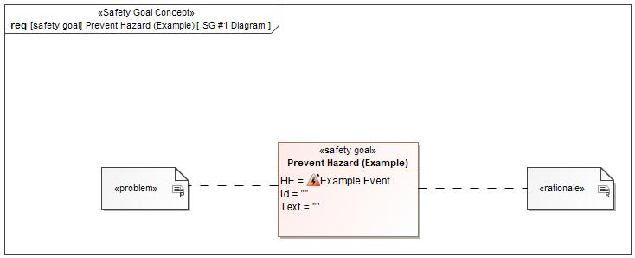

Figure 1: SG #1 Diagram – Prevent Hazard (Example)

*Note: The authoritative source for the Safety Goals is document “FFSD 02 Hazard Analysis* *and Risk Assessment”. The documentation of Safety Goals in this chapter (In the Argumentation for Safety Goal achievement) is for information purposes only.*

*The authoritative source for the Functional Safety Requirements is section 2.1.x.3: of this document. The documentation of Functional Safety Requirements in the following chapter (complete or summarised) is for information purposes only.*

#### Warning and Recovery Concept

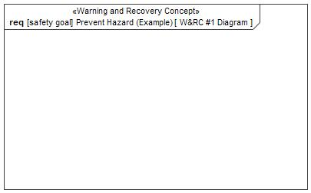

Figure 6: W&RC #1 Diagram – Prevent Hazard (Example)

#### FSRs for - Prevent Hazard (Example)

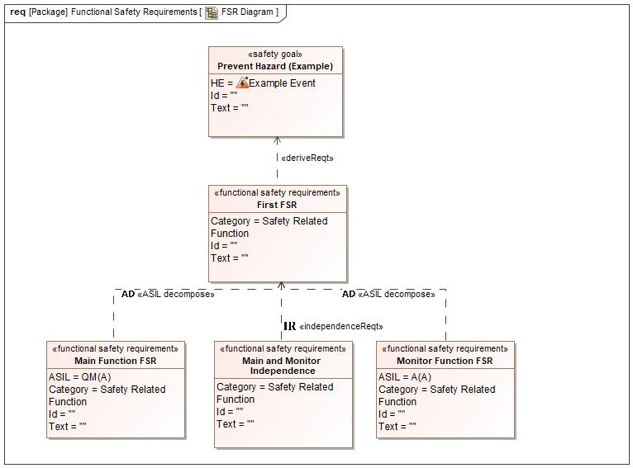

Figure 7. Prevent Hazard (Example)

Monitor Function FSR

Related to:

* Safe States:
  + Safe State #1
* Operating Modes:
  + Active Mode

|  |  |  |  |  |  |  |  |
| --- | --- | --- | --- | --- | --- | --- | --- |
| Requirement ID: | | | | | | | |
| **Purpose** |  | | | | | | |
| **V&V Acceptance Criteria** |  | | | | | | |
| **Notes** |  | | | | | | |
| **Source** |  | | | | | **Owner** |  |
| **Source Req.** | * -785392055.jpg Prevent Hazard (Example) | | | | | **V&V Method** |  |
| **Type** | N/A | | **Priority** | | N/A | **Status** |  |
| **ASIL** | A(A) | | **Category** | | Safety Related Function | **Fault Handling Time** | N/A |
| [Req. Template](http://wiki.ford.com/display/RequirementsEngineering/Requirements+Attributes) Version | | 6.0 | | End of Requirement | | | |

Main and Monitor Independence

Related to:

* Safe States:
  + Safe State #1
* Operating Modes:
  + Active Mode

|  |  |  |  |  |  |  |  |
| --- | --- | --- | --- | --- | --- | --- | --- |
| Requirement ID: | | | | | | | |
| **Purpose** |  | | | | | | |
| **V&V Acceptance Criteria** |  | | | | | | |
| **Notes** |  | | | | | | |
| **Source** |  | | | | | **Owner** |  |
| **Source Req.** | * -785392055.jpg Prevent Hazard (Example) | | | | | **V&V Method** |  |
| **Type** | N/A | | **Priority** | | N/A | **Status** |  |
| **ASIL** |  | | **Category** | | Safety Related Function | **Fault Handling Time** | N/A |
| [Req. Template](http://wiki.ford.com/display/RequirementsEngineering/Requirements+Attributes) Version | | 6.0 | | End of Requirement | | | |

First FSR

Related to:

* Safe States:
  + Safe State #1
* Operating Modes:
  + Active Mode

|  |  |  |  |  |  |  |  |
| --- | --- | --- | --- | --- | --- | --- | --- |
| Requirement ID: | | | | | | | |
| **Purpose** |  | | | | | | |
| **V&V Acceptance Criteria** |  | | | | | | |
| **Notes** |  | | | | | | |
| **Source** |  | | | | | **Owner** |  |
| **Source Req.** | * -785392055.jpg Prevent Hazard (Example) | | | | | **V&V Method** |  |
| **Type** | N/A | | **Priority** | | N/A | **Status** |  |
| **ASIL** |  | | **Category** | | Safety Related Function | **Fault Handling Time** | N/A |
| [Req. Template](http://wiki.ford.com/display/RequirementsEngineering/Requirements+Attributes) Version | | 6.0 | | End of Requirement | | | |

Main Function FSR

Related to:

* Safe States:
  + Safe State #1
* Operating Modes:
  + Active Mode

|  |  |  |  |  |  |  |  |
| --- | --- | --- | --- | --- | --- | --- | --- |
| Requirement ID: | | | | | | | |
| **Purpose** |  | | | | | | |
| **V&V Acceptance Criteria** |  | | | | | | |
| **Notes** |  | | | | | | |
| **Source** |  | | | | | **Owner** |  |
| **Source Req.** | * -785392055.jpg Prevent Hazard (Example) | | | | | **V&V Method** |  |
| **Type** | N/A | | **Priority** | | N/A | **Status** |  |
| **ASIL** | QM(A) | | **Category** | | Safety Related Function | **Fault Handling Time** | N/A |
| [Req. Template](http://wiki.ford.com/display/RequirementsEngineering/Requirements+Attributes) Version | | 6.0 | | End of Requirement | | | |

### Derivation of Functional Safety Requirements on Assumptions

No Functional Safety Requirements tracing to Assumptions specified.

## ASIL Decomposition of Functional Safety Requirements

### Decomposition of Functional Safety Requirement

| Initial Safety Requirement | First FSR | |
| --- | --- | --- |
| Decomposition Rationale |  | |
| Method for Decomposition | A -> A(A) + QM(A) | |
| Functional Safety Requirement 1 after Decomposition | F-S-Req-ID |  |
| F-S-Req. Title | Monitor Function FSR |
| ASIL | A(A) |
| Rationale |  |
| Satisfied by |  |
| Functional Safety Requirement 2 after Decomposition | F-S-Req-ID |  |
| F-S-Req. Title | QM(A) |
| ASIL | Main Function FSR |
| Rationale |  |
| Satisfied by |  |
| Functional Safety Requirement for Independence | F-S-Req.-ID |  |
| F-S-Req. Title | Main and Monitor Independence |
| ASIL |  |
| Rationale |  |

# CyberSecurity

## Security Goals

|  |  |  |
| --- | --- | --- |
| ID | Goal | |
|  | **Goal Name** |  |
| **Description** |  |
| **CAL** |  |
| **Related CSR IDs** |  |
|  | **Goal Name** |  |
| **Description** |  |
| **CAL** |  |
| **Related CSR IDs** |  |
|  | **Goal Name** |  |
| **Description** |  |
| **CAL** |  |
| **Related CSR IDs** |  |

Table 15: Cybersecurity Goals

## Cybersecurity Requirements

# Architecture

## Functional Architecture

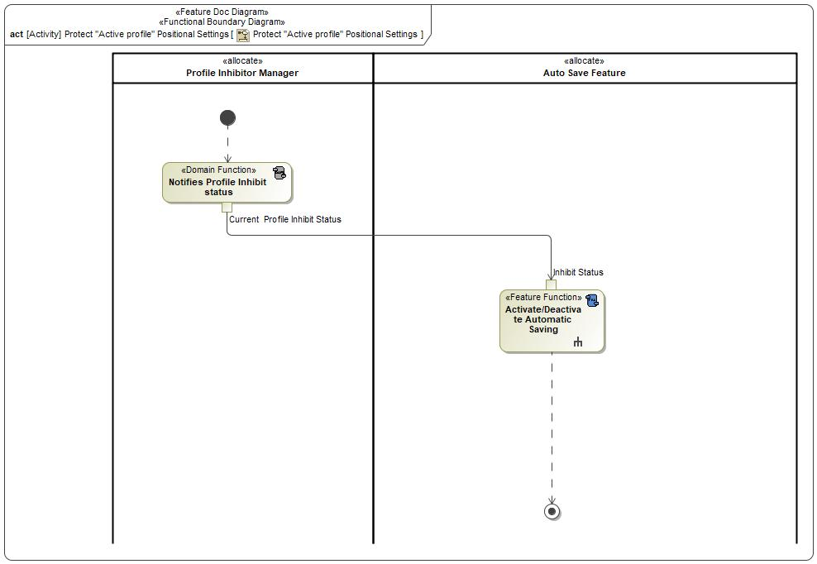

Figure 8: Protect "Active profile" Positional Settings

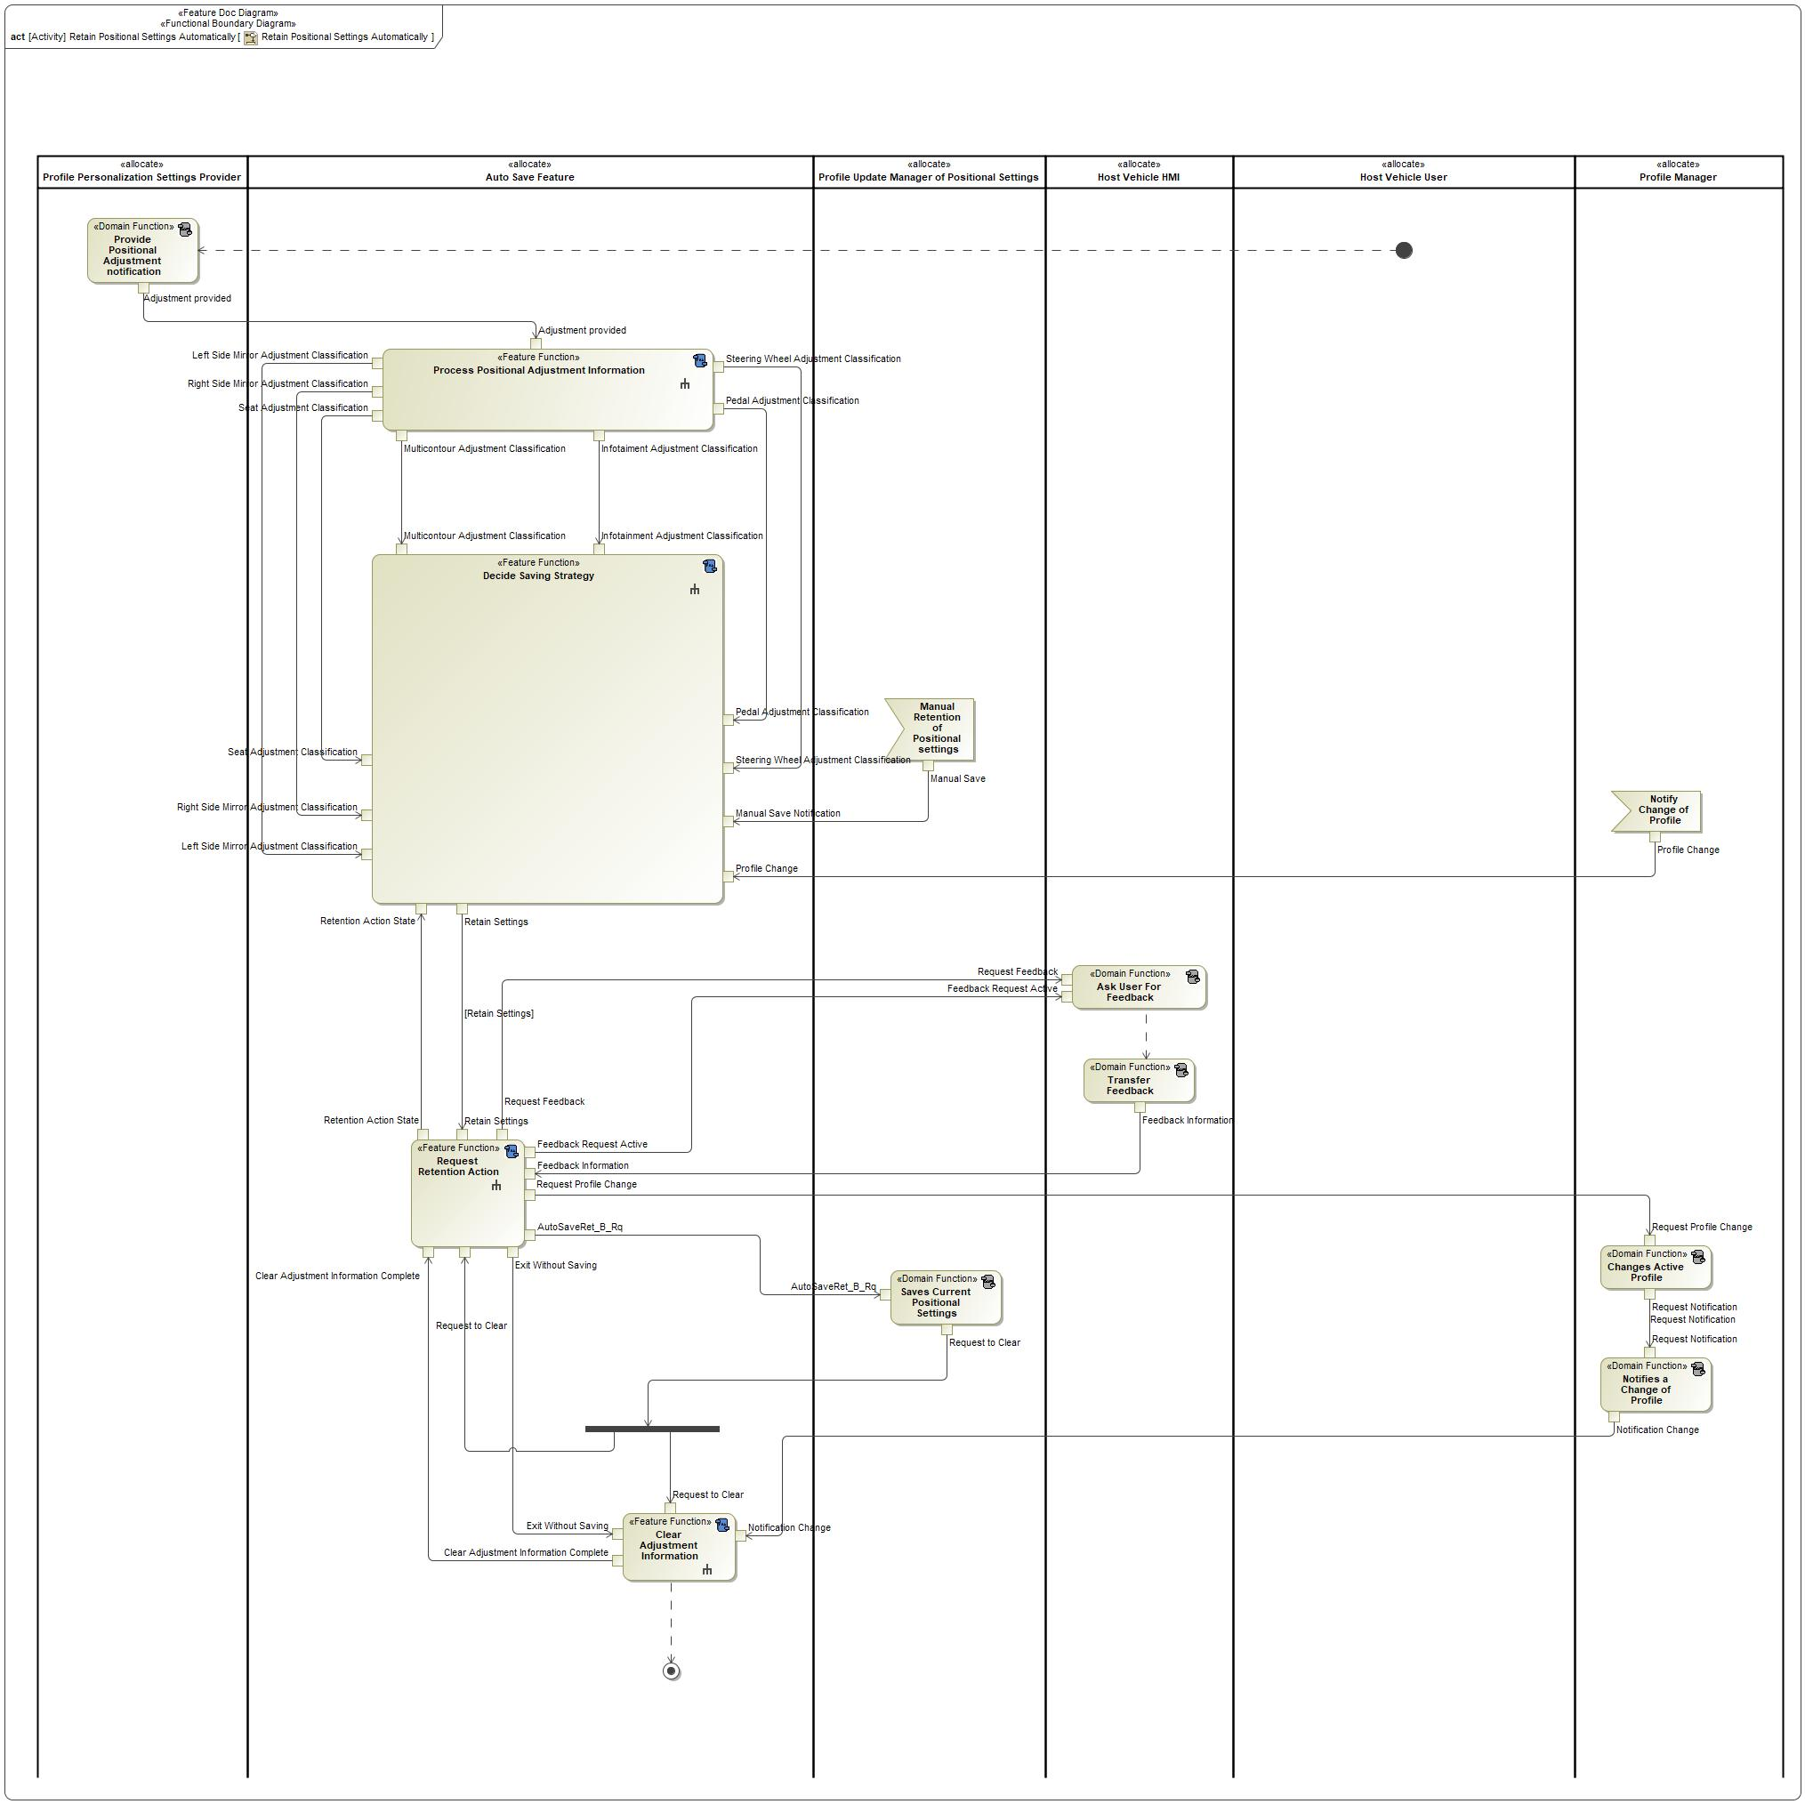

Figure 9: Retain Positional Settings Automatically

### List of Functions

| **Function Name** | Description | Comments |
| --- | --- | --- |
| *(activity)* Notifies Profile Inhibit status | *(activity)* DOMAIN FUNCTION - The Notify Profile Inhibit Status Functionality is the means by which an external entity informs Auto Save that its functionality should be inhibited. |  |
| *(activity)* Activate/Deactivate Automatic Saving | *(activity)* FEATURE FUNCTION - This feature function turns off and on Auto Save feature’s ability to process positional adjustments and decide what action to undertake. |  |

Table 16: List of Functions on Protect "Active profile" Positional Settings

| **Function Name** | Description | Comments |
| --- | --- | --- |
| *(activity)* Clear Adjustment Information | *(activity)* FEATURE FUNCTION - The Automatic Saving Feature keeps a list of adjustments that have arrived but are not yet processed. This function clears them to allow for additional processing. |  |
| *(activity)* Process Positional Adjustment Information | *(activity)* FEATURE FUNCTION - This function receives an alert that a positional adjustment has taken place and determines the type of adjustment. |  |
| *(activity)* Transfer Feedback | *(activity)* DOMAIN FUNCTION - This function will transfer the feedback provided to the user to any entity that needs it. |  |
| *(activity)* Request Retention Action | *(activity)* FEATURE FUNCTION - This function requests that the Profile Update Manager of Positional Settings retain the current positional settings in memory. |  |
| *(activity)* Decide Saving Strategy | *(activity)* FEATURE FUNCTION - Based on the adjustments that have arrived, this function determines whether to retain settings automatically or receive feedback from the Host Vehicle User. |  |
| *(activity)* Provide Positional Adjustment notification | *(activity)* DOMAIN FUNCTION - This function informs the Automatic Saving Feature that a positional adjustment has occurred, and it must respond to it. |  |
| *(activity)* Saves Current Positional Settings | *(activity)* DOMAIN FUNCTION - This function retains the current position of the positional settings in memory. |  |
| *(activity)* Ask User For Feedback | *(activity)* DOMAIN FUNCTION - This function of Host Vehicle HMI informs the Host Vehicle User that saving options are available. |  |
| *(activity)* Changes Active Profile | *(activity)* DOMAIN FUNCTION - This function of the Profile Manager switches the active profile. More information about what happens in this function can be found in “BEHAVIOR: Change User Profile”. |  |
| *(activity)* Notifies a Change of Profile | *(activity)* DOMAIN FUNCTION - This function will alert the Automatic Saving Feature that a change of profile has begun. |  |

Table 17: List of Functions on Retain Positional Settings Automatically

## Logical Architecture

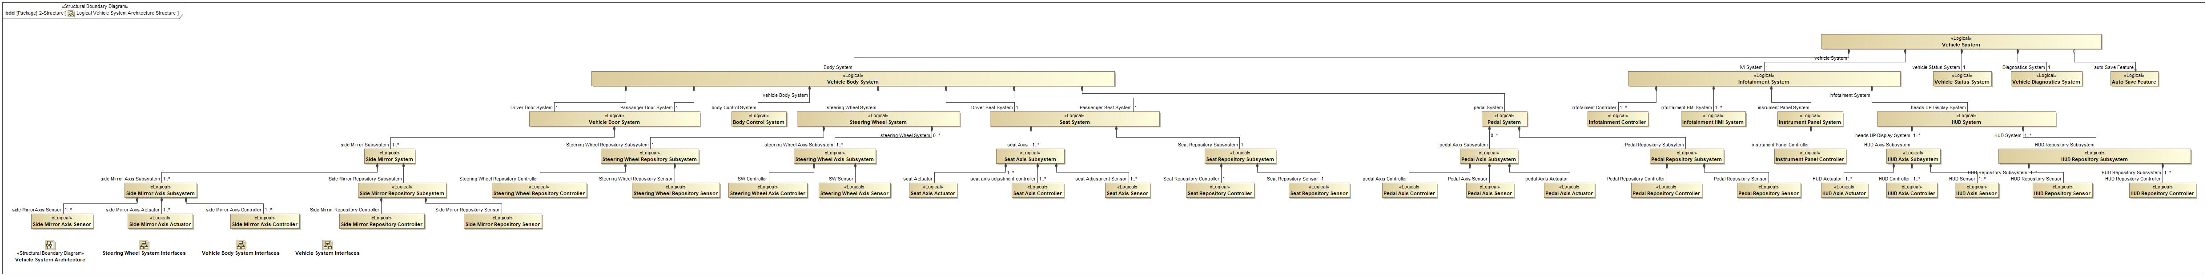

Figure 10: Logical Vehicle System Architecture Structure

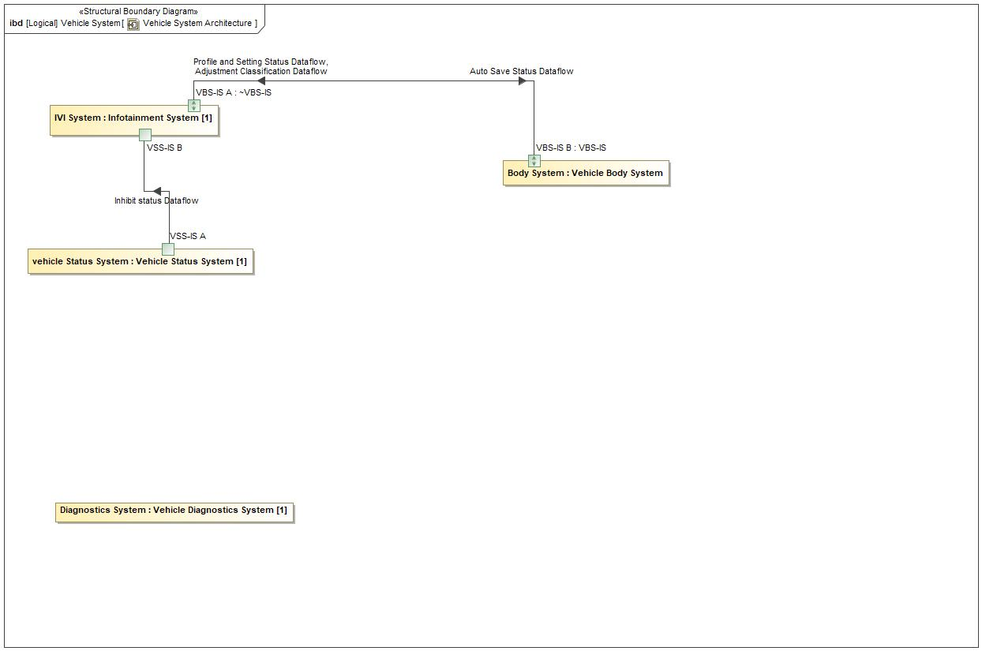

Figure 11: Vehicle System Architecture

### Logical Elements

|  |  |  |  |
| --- | --- | --- | --- |
| **Element Name** | **Description** | **Allocated Functions** | **Comments** |
| Auto Save Feature | The Auto Save Feature Logical refers to the logical elements that refines the Auto Save Feature at the logical level. It contains all the systems responsible for executing the Auto Save Feature (Compare, Monitor, Decide). |  |  |
| Body Control System | The Body Control System is responsible for changing profiles and updating settings on the vehicle. Auto Save requests profile changes and settings retentions from it. |  |  |
| HUD Axis Actuator | N/A for Auto Save |  |  |
| HUD Axis Controller | The HUD Axis Controller is the abstraction that determines how to respond to an adjustment has been made for a specific HUD Axis.  Owner: Farhan Sethi |  |  |
| HUD Axis Sensor | The HUD Axis Sensor is the abstraction that determines that an adjustment has been made for a specific HUD Axis.  Owner: Farhan Sethi |  |  |
| HUD Axis Subsystem | The HUD Axis Subsystem is the abstraction that encompasses the system and features that are responsible for executing the Automatic Saving functionality relating to a specific HUD Axis.  Owner: Farhan Sethi |  |  |
| HUD Repository Controller | The HUD Repository Controller is the abstraction that controls the HUD Adjustment Repository.  Owner: Farhan Sethi |  |  |
| HUD Repository Sensor | The HUD Repository Sensor is the abstraction that detects changes to the HUD Repository.  Owner: Farhan Sethi |  |  |
| HUD Repository Subsystem | The HUD Repository Subsystem is the abstraction that contains the HUD Adjustment Repository.  Owner: Farhan Sethi |  |  |
| HUD System | The HUD System is the abstraction that encompasses the system and features that are responsible for executing the Automatic Saving functionality relating to the HUD.  Owner: Farhan Sethi |  |  |
| Infotainment Controller | The Infotainment Controller is the abstraction that encompasses the system and features that are responsible for executing the Decide Functional Group of the Auto Save feature.  Auto Save is comprised of two functional groups: Decide and Monitor/Compare. The Monitor/Compare Functional Group is responsible for monitoring the adjustments the user has made to positional settings and classifying them.  The Decide Functional Group comprises the control aspects of the Automatic Saving functionality. It receives the classifications of positional settings from the Monitor/Compare Functional Group. It stores these settings in the Classified Adjustments Repository. Based on these classifications, the Decide Functional Group will save immediately or prompt the user for feedback. The feedback is then used to save the adjustments, ignore further adjustments, or change the profile.  Owner: Matt Borrelli, IVI SPSS Author |  |  |
| Infotainment HMI System | The Vehicle HMI System is responsible for interacting with the user. It requests input from the user and provides the user’s response to the Auto Save Decide System. |  |  |
| Infotainment System | The Infotainment System is the abstraction that encompasses the system and features that are responsible for executing the Automatic Saving functionality relating to driver information, as well as the bulk of the Auto Save algorithm.  Owner: Unknown |  |  |
| Instrument Panel Controller | N/A for Auto Save |  |  |
| Instrument Panel System | N/A for Auto Save |  |  |
| Pedal Axis Actuator | The Pedal Axis Actuator is the abstraction that moves a specific Pedal Axis.  Owner: Jonathan Iaquinto |  |  |
| Pedal Axis Controller | The Pedal Axis Controller is the abstraction that determines how to respond to an adjustment has been made for a specific Pedal Axis.  Owner: Jonathan Iaquinto |  |  |
| Pedal Axis Sensor | The Pedal Axis Sensor is the abstraction that determines that an adjustment has been made for a specific Pedal Axis.  Owner: Jonathan Iaquinto |  |  |
| Pedal Axis Subsystem | The Pedal Axis Subsystem is the abstraction that encompasses the system and features that are responsible for executing the Automatic Saving functionality relating to a specific Pedal Axis.  Owner: Jonathan Iaquinto |  |  |
| Pedal Repository Controller | The Pedal Repository Controller is the abstraction that controls the Pedal Adjustment Repository.  Owner: Jonathan Iaquinto |  |  |
| Pedal Repository Sensor | The Pedal Repository Sensor is the abstraction that detects changes to the Pedal Repository.  Owner: Jonathan Iaquinto |  |  |
| Pedal Repository Subsystem | The Pedal Repository Subsystem is the abstraction that contains the Pedal Adjustment Repository.  Owner: Jonathan Iaquinto |  |  |
| Pedal System | The Pedal System is the abstraction that encompasses the system and features that are responsible for executing the Automatic Saving functionality relating to the pedals.  Owner: Jonathan Iaquinto |  |  |
| Seat Axis Actuator | The Seat Axis Actuator is the abstraction that moves a specific Seat Axis.  Owner: Jonathan Iaquinto |  |  |
| Seat Axis Controller | The Seat Axis Controller is the abstraction that determines how to respond to an adjustment has been made for a specific Seat Axis.  Owner: Jonathan Iaquinto |  |  |
| Seat Axis Sensor | The Seat Axis Sensor is the abstraction that determines that an adjustment has been made for a specific Seat Axis.  Owner: Jonathan Iaquinto |  |  |
| Seat Axis Subsystem | The Seat Axis Subsystem is the abstraction that encompasses the system and features that are responsible for executing the Automatic Saving functionality relating to a specific Seat Axis.  Owner: Jonathan Iaquinto |  |  |
| Seat Repository Controller | The Seat Repository Controller is the abstraction that controls the Seat Adjustment Repository or Multicontour Adjustment Repository, depending on configuration.  Owner: Jonathan Iaquinto |  |  |
| Seat Repository Sensor | The Seat Repository Sensor is the abstraction that detects changes to the Seat Repository.  Owner: Jonathan Iaquinto |  |  |
| Seat Repository Subsystem | The Seat Repository Subsystem is the abstraction that contains the Seat Adjustment Repository or Multicontour Adjustment Repository, depending on configuration.  Owner: Jonathan Iaquinto |  |  |
| Seat System | The Seat System is the abstraction that encompasses the system and features that are responsible for executing the Automatic Saving functionality relating to a seat, whether it is a driver seat, passenger seat, or other seat.  Owner: Jonathan Iaquinto |  |  |
| Side Mirror Axis Actuator | The Side Mirror Axis Actuator is the abstraction that moves a specific Side Mirror Axis.  Owner: Newton Filho, Ibaa Al-Hayek |  |  |
| Side Mirror Axis Controller | The Side Mirror Axis Controller is the abstraction that determines how to respond to an adjustment has been made for a specific Side Mirror Axis.  Owner: Newton Filho, Ibaa Al-Hayek |  |  |
| Side Mirror Axis Sensor | The Side Mirror Axis Sensor is the abstraction that determines that an adjustment has been made for a specific Side Mirror Axis.  Owner: Newton Filho, Ibaa Al-Hayek |  |  |
| Side Mirror Axis Subsystem | The Side Mirror Axis Subsystem is the abstraction that encompasses the system and features that are responsible for executing the Automatic Saving functionality relating to a specific mirror axis.  Owner: Newton Filho, Ibaa Al-Hayek |  |  |
| Side Mirror Repository Controller | The Side Mirror Repository Controller is the abstraction that controls the Left Side Mirror Adjustment Repository or Right Side Mirror Adjustment Repository, depending on configuration.  Owner: Newton Filho, Ibaa Al-Hayek |  |  |
| Side Mirror Repository Sensor | The Side Mirror Repository Sensor is the abstraction that detects changes to the Side Mirror Repository.  Owner: Newton Filho, Ibaa Al-Hayek |  |  |
| Side Mirror Repository Subsystem | The Side Mirror Repository Subsystem is the abstraction that contains the Left Side Mirror Adjustment Repository or Right Side Mirror Adjustment Repository, depending on configuration.  Owner: Newton Filho, Ibaa Al-Hayek |  |  |
| Side Mirror System | The Side Mirror System is the abstraction that encompasses the system and features that are responsible for executing the Automatic Saving functionality relating to a mirror, whether it is a driver or passenger mirror.  Owner: Newton Filho, Ibaa Al-Hayek |  |  |
| Steering Wheel Axis Controller | The Steering Wheel Axis Controller is the abstraction that determines how to respond to an adjustment has been made for a specific Steering Wheel Axis.  Owner: Jonathan Iaquinto |  |  |
| Steering Wheel Axis Sensor | The Steering Wheel Axis Sensor is the abstraction that determines that an adjustment has been made for a specific Steering Wheel Axis.  Owner: Jonathan Iaquinto |  |  |
| Steering Wheel Axis Subsystem | The Steering Wheel Axis Subsystem is the abstraction that encompasses the system and features that are responsible for executing the Automatic Saving functionality relating to a specific Steering Wheel Axis.  Owner: Jonathan Iaquinto |  |  |
| Steering Wheel Repository Controller | The Steering Wheel Repository Controller is the abstraction that controls the Steering Wheel Adjustment Repository.  Owner: Jonathan Iaquinto |  |  |
| Steering Wheel Repository Sensor | The Steering Wheel Repository Sensor is the abstraction that detects changes to the Steering Wheel Repository.  Owner: Jonathan Iaquinto |  |  |
| Steering Wheel Repository Subsystem | The Steering Wheel Repository Subsystem is the abstraction that contains the Steering Wheel Adjustment Repository.  Owner: Jonathan Iaquinto |  |  |
| Steering Wheel System | The Steering Wheel System is the abstraction that encompasses the system and features that are responsible for executing the Automatic Saving functionality relating to the steering column.  Owner: Jonathan Iaquinto |  |  |
| Vehicle Body System | The Vehicle Body System is the abstraction that encompasses the system and features that are responsible for executing the Automatic Saving functionality relating to cabin comfort.  Owner: Unknown |  |  |
| Vehicle Diagnostics System | The Vehicle Diagnostics System is responsible for modifying the configurable parameters of the Auto Save Feature. |  |  |
| Vehicle Door System | The Vehicle Door System is the abstraction that encompasses the system and features that are responsible for executing the Automatic Saving functionality relating to a mirror, whether it is on a driver or passenger door.  Owner: Newton Filho, Ibaa Al-Hayek |  |  |
| Vehicle Status System | The Vehicle Status System provides the current status of the vehicle in terms of the vehicle mode, ignition status, and system time. |  |  |
| Vehicle System | The vehicle is the abstraction that encompasses the system and features that are responsible for executing the Automatic Saving functionality.  Owner: Unknown |  |  |

Table 18: Logical Elements

### Logical Interfaces

|  |  |  |  |
| --- | --- | --- | --- |
| **Interface** | **Direction** | **Description** | **Value Range** |
| Adjustment Classification Dataflow | VBS-IS B (Vehicle Body System) To VBS-IS A (Infotainment System) | The Adjustment Classification Dataflow connects the systems that comprise the Vehicle Body System, which are responsible for classifying each subdomain, to the Infotainment System, which determines what action should be taken based on those classifications. | Pedal Adjustment Classification  Multicontour Adjustment Classification  Seat Adjustment Classification  Right Mirror Adjustment Classification  Left Mirror Adjustment Classification  Steering Wheel Adjustment Classification |
| Auto Save Status Dataflow | VBS-IS A (Infotainment System) To VBS-IS B (Vehicle Body System) | The Auto Save Status Dataflow provides the control actions of the Auto Save Feature. These control actions include saving, clearing the repositories, and the status of the Auto Save Feature. | Activation Status  as Activation Status:   * Disabled * Enabled Inactive * Enabled Active   Request Save  as Request Save:   * Request Save   as Request Save:   * Save * No Save   Exit Without Saving  as Exit Without Saving:   * Exit Without Saving   Decide Feedback  as Decide Feedback: |
| Inhibit status Dataflow | VSS-IS A (Vehicle Status System) To VSS-IS B (Infotainment System) | The Inhibit Status Dataflow connects the Vehicle Status System to the Infotainment System. It contains inhibit status messages that change the Auto Save feature status. | Inhibit Status  as Inhibit Change Notification:   * Inhibit Status Change |
| Profile and Setting Status Dataflow | VBS-IS B (Vehicle Body System) To VBS-IS A (Infotainment System) | The Profile and Setting Status Dataflow provides information from the Vehicle Body System to the Auto Save Feature in the Infotainment System. | Notification Change  as Notification Status:   * unnamed1   Request to Clear  as Clear Request:   * Request to Clear   Profile Change Notification  as Request Profile Change:   * Change Profile * No Change   as Request Profile Change:   * Request Profile Change   Manual Save  as Manual Save Request: |

Table 19: Feature Interactions on Vehicle System Architecture

# Open Concerns

| ID | Concern Description | e-Tracker / Reference | Responsible | Status | Solution |
| --- | --- | --- | --- | --- | --- |
| 1 |  |  |  |  |  |

Table 20: Open Concerns *(Not supported by MagicDraw report generation)*

# Revision History

|  |  |  |
| --- | --- | --- |
| Rev | Date Released | Release Notes |
| A | 2020/03/24 | In-progress draft version from 2019/09/05, docx format |
| B | 2020/03/24 | In-progress draft version from 2019/09/05, pdf format |
| C | 2020/05/22 | In-progress draft version from 2019/05/22, docx format |
| D | 2020/08/03 | In-progress draft version from 2019/06/29, docx format |
| E | 2020/10/06 | Initial Release, docx format |
| F | 2021/03/08 | Removal of extraneous requirements  Addition of Data Analytics requirements  Realignment with membership in PPP feature  Revised Logical Architecture |

## Template Revisions

|  |  |  |  |  |
| --- | --- | --- | --- | --- |
| Version | Rev. | Date | Description | Responsible |
| *0* | *6* | *2015-05-26* | * *Chapter “Feature Overview” and made a 2nd level heading.* * *Chapter “Feature Modeling” divided into 3 subchapter (“Scenarios”, “Use Cases”, “State Machines”) for different modeling methods* | *Jbaden1* |
| *0* | *7* | *2015-05-27* | * *Table of Content updated* * *Template Revision History chapter added* | *Jbaden1* |
| *0* | *8* | *2015-07-02* | * *Section “Unsettled Issues” added* | *Alevin7* |
| *0* | *9* | *2015-08-04* | * *Section “Feature Variants” added* * *Section “Feature Boundary Diagram” renamed to “Feature Context Diagram”* * *Document Properties adapted to match needs of VBA macros* | *Jbaden1, Awegman1* |
| *1* | *0* | *2015-09-11* | * *Section “Feature Variants” reworked* * *Feature Goals removed. Only “Safety Goals“ chapter remains.* * *Heading 2 formatting issues corrected.* * *Requirements / Use Cases Listing removed from traceability chapter.* * *Formatting of attribute table in Notation chapter corrected* * *Open Topics / Known Issues chapter moved to the end* | *Jbaden1* |
| *1* | *1* | *2015-11-16* | * *Table-Styles removed (for smooth VSEM import)* * *Some clean-up of sections “Purpose” and “Audience”* | *Awegman1, jbaden1* |
| *1* | *2* | *2016-02-26* | * *Minor corrections based on lessons learned from CC and PCL pilot (e.g. section market/regions) and discussion with Functional Safety Team (purpose of feature)* * *Footer corrected* * *Boundary diagram interface chapter renamed to influences.* | *Jbaden1* |
| *1* | *3* | *2016-02-26* | * *Minor corrections after review with Whitney Keith from Functional Safety team* | *Jbaden1* |
| *1* | *4* | *2016-03-10* | * *Some cleanup of meta-data in Word Properties* | *Jbaden1* |
| *1* | *5* | *2016-03-10* | * *Footer formatting corrected (Issue 19)* * *Results from review with Functional Safety Team incorporated (Issue 20).* | *jbaden1* |
| *1* | *6* | *2016-04-18* | * *Scenario Template added* | *Jbaden1* |
| *1* | *7* | *2016-04-18* | * *Chapter “Operation Modes and States” moved before “Use Case” section.* | *Jbaden1* |
| *1* | *8* | *2016-04-18* | * *Broken Wiki links repaired.* | *Jbaden1* |
| *2* | *0* | *2016-05-19* | * *Adapted to Specification_Macros.dotm V2.0* * *Requirements Templates chapter (ch. 1.7.1) no longer has an attribute table, but refers directly to the Wiki..* | *Jbaden1* |
| *2* | *1* | *2016-06-10* | * *Table for Context Diagram modified (lists external entities and Influence Description only)* | *Jbaden1* |
| *2* | *2* | *2016-07-08* | * *Template version added to footer* * *Several hints added to the various sections* * *Findings from Functional Safety Team incorporated.* * *RE_SafetyRequirement style added* | *Jbaden1* |
| *2* | *3* | *2016-09-21* | * *Update from Functional Safety Team incorporated (“Lessons Learned”, “System Behaviors for HARA”)* | *Jbaden1* |
| *2* | *4* | *2016-11-15* | * *Update from Functional Safety Team incorporated (“Lessons Learned”, “System Behaviors for HARA”)* * *Explanatory notes made more formal* | *Jbaden1* |
| *3* |  |  | *Skipped to synchronize with Specification_Macros.dotm* |  |
| *4* |  |
| *5* | *0* | *2017-01-13* | * *Meta data updated for specification macros, version 3.1* * *SW Unit chapter removed for the time being* * *Green boxes added for user hints* | *Jbaden1* |
| *5* | *1* | *2017-01-18* | * *Minor editorial changes* | *Jbaden1* |
| *6* | *0* | *2017-02-03* | * *CR48: Chapter 6 renamed from “Safety” to “Functional Safety”. New sub-chapter “Safety” introduced in Non-Functional Requirements section* | *Jbaden1* |
| *6* | *0* | *2017-04-28* | * *CR7: “RequirementsTraceability” chapter removed* | *Jbaden1* |
| *6* | *0* | *2017-11-15* | * *CR32/53: New Cover Sheet + Disclaimer replaces FAP-150 like ones.* * *CR75: Some rewording -> Terminology to Glossary, Notation -> Document Conventions* * *CR49: Rename “Assumptions & Constraints” to “Assumptions”* * *CR74: Safety Assumptions added to chapter 6.* * *CR58: Add function allocation column to Logical Architecture chapter* | *Jbaden1* |
| *6* | *0* | *2018-01-31* | * *CR63: Updated links to Functional Safety Sharepoint* | *Jbaden1* |
| *6* | *0* | *2018-07-24* | * *CR69: Add FSR to FeatureDoc* * *CR64: Add new section "Design Requirements" to Function Spec and Feature Spec* | *Jbaden1* |
| *6* | *0* | *2018-08-06* | * *CR53: some corrections for metada and formatting* | *Jbaden1* |
| *6* | *0* | *2018-09-28* | * *Broken links to RE Wiki repaired* | *Jbaden1* |
| *6* | *0* | *2018-10-31* | * *Cover sheet and footer more GIS like. Functional Safety team feedback incorporated:*   + *New subsections “Functional Safety Requirements, (Decomposed) FSRs and Parameters / Values*   + *Removal of “Logical Architecture”* | *Jbaden1* |
| *6* | *0* | *2018-12-12* | * *FSR template removed, now as a macro in the Specification_Macros.dotm* | *Jbaden1* |
| *N* |  | *2019-04-03* | * *Updated code for context diagrams, actors and use cases.* * *Updated code structure with all macros at the beginning.* * *Updated code to populate assumptions using element-assumption relationship or hazardous event.* | *snuesch* |
| *N* |  | *2019-04-18* | * *Added structural boundary diagram for FuSa based on TGB discussion.* * *Added operating modes to functional safety requirements.* | *snuesch* |
| *N* |  | *2019-04-25* | * *Improved export of actions and activities on functional boundary diagram.* | *snuesch* |
| *6* | *0b* | *2019-05-23* | * *Re-introduce “Logical Architecture” (for Functional Safety)* | *Jbaden1* |
| *N* |  | *2019-06-17* | * *Aligned “Architecture” section with RE template.* * *Made “Ford Documents” table more flexible.* * *Added template terms to glossary* | *snuesch* |
| *N* |  | *2019-06-25* | * *Improved use cases to handle Primary and Secondary actors.* * *Added Performance Requirements to Uncategorized.* | *snuesch* |
| *6* | *0b* | *2019-06-26* | * *Chapter “Logical Elements” in “Logical Architecture” section added (FuSa CR 15136240)* * *“References” and “Glossary” chapter moved from section “Feature Overview” to “Introduction”. References and Glossary should be available in the document as early as possible* | *Jbaden1* |
| *N* |  | *2019-07-25* | * *Added populated “Logical Elements” table and allocated functions.* * *Export documentation field of context diagram.* | *snuesch* |
| *N* |  | *2019-08-09* | * *Export documentation field of use case diagram.* * *Fixed bug in Feature Requirement Verification Method.* * *Simplified export of References without publisher.* | *snuesch* |
| *N* |  | *2019-08-21* | * *Improved glossary and acronym tables* | *snuesch* |
| *N* |  | *2019-08-28* | * *Fixed bug in populating title in header* | *snuesch* |
| *N* |  | *2019-09-16* | * *Updated bibliography export* | *snuesch* |
| *N* |  | *2019-09-27* | * *Updated export of Verification Method and Requirement Status for Feature Requirements and V&V Method for Functional Safety Requirements.* | *snuesch* |

# Appendix

## Definitions

| **Definition** | **Description** |
| --- | --- |
| Action State | An Action State refers to one of the states of the Auto Save algorithm. |
| Action Validation Criteria | Validation criteria for these actions |
| Activation Preconditions | The preconditions for Auto Save activation are (Feature_Precondition_Status):  1. The vehicle has the Auto Save feature configured ON  2. The Vehicle Mode is Normal  3. The ignition status of the vehicle is Run, Start, or Accessory or the HMI status is Extended Play  4. A software update is not occurring on the vehicle  5. A technician has not placed the vehicle in diagnostics mode |
| Adjustment Repository | An Adjustment Repository is a storage area for adjustment classifications within each Auto Save Subdomain. The Adjustment Repository consists of a table that includes each axis in the subdomain, indexed by 'Axis ID', and the classification of the adjustment for that axis. |
| Adjustment Time Constant | Configurable parameter that indicates how long the Auto Save algorithm will wait for a position adjustment when in a gear other than reverse.  Currently defined as 10 seconds. |
| AHU | Audio Head Unit |
| AHUD | Advanced Heads-Up Display |
| Antropometric Translation | An enhancement to Personal and Portable Profiles, Anthropometric Translation is an algorithm that can translate user positions from one vehicle to another. |
| APIM | Accessory Protocol Interface Module |
| Auto Save Domain | The Auto Save Domain consists of commodities capable of modifying and retaining Positional Adjustments. These commodities include:  1) Driver Seat, including Multi-Contour Lumbar Support  2) Side Mirrors, including Reverse Tilt Control  3) Foot Pedals  4) Steering Column  5) HUD, including Brightness Control  6) Passenger Seat, including Multi-Contour Lumbar Support |
| Axis Controller | An Axis Controller is an ECU or part of an ECU that can read the current position of an axis and the saved position of an axis. It is responsible for executing much of the processing of Auto Save's Monitor/Compare Functional Group. |
| Axis ID | The Axis ID is an integer that identifies each axis in the Auto Save Domain. It is unique to every axis. |
| Axis Sensor | An Axis Sensor is used to measure the position of an axis (for common adjustments); or to indicate that changes have occurred to an axis (for rare adjustments). |
| BCM | Body Control Module |
| BCS-PS Interface | The interface by which the Body Control System informs the Pedal System that settings have been retained. |
| BCS-SS Interface | The interface by which the Body Control System informs the Seat System that settings have been retained. |
| BCS-SWS Interface | The interface by which the Body Control System informs the Steering Wheel System that settings have been retained. |
| BCS-VDS Interface | The interface by which the Body Control System informs the Vehicle Door System that settings have been retained. |
| Body Control System | The Body Control System is responsible for changing profiles and updating settings on the vehicle. Auto Save requests profile changes and settings retentions from it. |
| CAN | Controller Area Network |
| CAPM | Column and Pedal Module |
| CGEA | Common Global Electrical Architecture |
| Classic Memory | The traditional means of saving positional settings to memory. Utilizes two or three memory buttons that the user uses to save and recall positional settings. |
| Classified Adjustments Repository | The Classified Adjustments Repository is a special Adjustment Repository on the Infotainment Controller. It keeps track of the combined adjustments from every Auto Save Domain. It supplies the Auto Save algorithm with the current state of adjustments. |
| Common | Common is a type of axis. Common axes are those that are adjusted frequently. Auto Save will classify adjustments to common axes based on a threshold. |
| Conditions for Clearing | The Auto Save feature will clear information from its repositories when any of the following conditions are TRUE:  1. The value of 'Auto Save Active Status' transitions from 'Enabled Active' to 'Enabled Inactive' or 'Disabled'  2. The Profile Update Manager of Positional Settings sets the value of 'Clear Request' to 'Store_1', 'Store_2', 'Store_3', or 'Store_4'  3. The Profile Manager changes the value of 'Notification Change' to 'Recall_1', 'Recall_2', 'Recall_3', or 'Recall_4'  4. The value of 'Exit Without Saving' is 'Yes' |
| DCU | Door Control Unit |
| DDM | Driver Door Module |
| DID | Data Identifier |
| Disabled | One of the states of Auto Save Active Status. Indicates that the feature is not in operation on the vehicle. Auto Save settings will not be visible to the user when in this state. |
| Driver Actions or Others | Description of driver actions or other people |
| DSM | Driver Seat Module |
| DSP | Digital Signal Processing |
| DTC | Diagnostic Trouble Code |
| Easy Entry Easy Exit | The Easy Entry Easy Exit system modifies the position of the seat and steering wheel to enable easy ingress to and egress from the vehicle |
| ECG | Enhanced Central Gateway |
| ECU | Electronic Control Unit |
| Enabled Active | One of the states of Auto Save Active Status. Indicates that the feature is in full operation on the vehicle. Auto Save settings are visible to the user when in this state. |
| Enabled Inactive | One of the states of Auto Save Active Status. Indicates that the feature is in operation on the vehicle, but is temporarily off due to inhibition. Auto Save settings will be visible to the user when in this state. |
| Enhanced Memory | An improvement to Classic Memory, Enhanced Memory allows the user to create and name a profile, thus creating a Personal Profile. The user can link the profile to a Classic Memory button, a phone, and a key fob. |
| EOI | Element of Interest |
| EOL | End Of Line |
| FCIM | Front Control Interface Module |
| FS | Function (Group) Specification |
| FTTI | Fault Tolerance Time Interval |
| Functional Redundancies | Functional redundancy - fault tolerance |
| GAPM | Global Advance Program Marketing |
| Guest Profile | The Guest Profile is a type of Profile that is active when an unauthenticated user is in the vehicle. |
| HMI | Human Machine Interface |
| HUD | Head-Up Display |
| HUD Adjustment Repository | An Adjustment Repository for holding adjustments in the HUD Sub-Domain. |
| HUD Axis Controller | The HUD Axis Controller is the abstraction that determines how to respond to an adjustment has been made for a specific HUD Axis.  Owner: Farhan Sethi |
| HUD Axis Sensor | The HUD Axis Sensor is the abstraction that determines that an adjustment has been made for a specific HUD Axis.  Owner: Farhan Sethi |
| HUD Axis Subsystem | The HUD Axis Subsystem is the abstraction that encompasses the system and features that are responsible for executing the Automatic Saving functionality relating to a specific HUD Axis.  Owner: Farhan Sethi |
| HUD Repository Controller | The HUD Repository Controller is the abstraction that controls the HUD Adjustment Repository.  Owner: Farhan Sethi |
| HUD Repository Subsystem | The HUD Repository Subsystem is the abstraction that contains the HUD Adjustment Repository.  Owner: Farhan Sethi |
| HUD System | The HUD System is the abstraction that encompasses the system and features that are responsible for executing the Automatic Saving functionality relating to the HUD.  Owner: Farhan Sethi |
| HUD-HUDAS Interface | The interface by which the HUD System provides the HUD Axis Subsystem with the Auto Save Feature's control flows. |
| HUD-HUDRS Interface | The interface by which the HUD System provides the HUD Repository Subsystem with the Auto Save Feature's control flows. It is also the means by which the HUD Repository System reports the combined classification of all the axes in the HUD System. |
| HUD-IC Interface | The interface by which the Infotainment Controller provides the HUD System with the Auto Save Feature’s control flows. It is also the interface by which the HUD System provides the Infotainment Controller with the HUD adjustment classification. |
| HUDAS-HUDAC Interface | The interface by which the HUD Axis Subsystem provides the HUD Axis Controller with the Auto Save Feature’s control flows. It is also the means by which the HUD Axis Controller reports the current classification of its axis. |
| HUDAS-HUDASE Interface | The interface by which the HUD Axis Subsystem provides the HUD Axis Sensor with the Auto Save Feature’s control flows. |
| HUDAS-HUDRC Interface | The interface by which the HUD Repository Subsystem provides the HUD Repository Controller with the Auto Save Feature’s control flows and the adjustment classifications of every axis in the HUD System. It is also the means by which the HUD Repository Controller reports the combined classification of all the axes in the HUD System. |
| HUDAS-HUDRS Interface | The interface by which the HUD Axis Subsystem provides the HUD Repository Subsystem with the adjustment classifications of every axis in the HUD System. |
| HUDASE-HUDAC Interface | The interface by which a HUD Axis Sensor can indicate to the HUD Axis Controller than an adjustment has occurred. |
| Idle | The Idle action state is a special waiting state where the Auto Save feature waits for a position adjustment to occur. One a position adjustment occurs, the Auto Save algorithm will determine what to do to respond. |
| Ignore Time Constant | Configurable parameter that indicates how long Auto Save will inform the user that their changes will not be retained. |
| IHMIS-IC Interface | The interface by which the Infotainment Controller requests feedback from the Infotainment HMI System. It is also the interface by which the Infotainment HMI System provides the Infotainment Controller with the user's response. |
| IKT | Integrated Key Transmitter |
| Infotainment Controller | The Infotainment Controller is the entity responsible for executing the Decide Functional Group of the Auto Save feature. It receives consolidated adjustments from each Auto Save Sub-Domain and decides what retention action to take. It is assumed that the Infotainment Controller will be allocated to the ECG. |
| Infotainment HMI System | The Vehicle HMI System is responsible for interacting with the user. It requests input from the user and provides the user’s response to the Auto Save Decide System. |
| Infotainment System | The Infotainment System is the abstraction that encompasses the system and features that are responsible for executing the Automatic Saving functionality relating to driver information, as well as the bulk of the Auto Save algorithm.  Owner: Unknown |
| Inhibit Request | There are active inhibit requests (Inhibit_Request) when one or more of the following conditions are true:  1. The Profile Positional Settings Manager (Enhanced Memory) disables the Auto Save Feature in the profile on the vehicle  2. An Easy Entry Easy Exit event is active on the vehicle  3. The profile active on the vehicle is not a user profile  4. A profile resume event is occurring on the vehicle |
| Inhibit Table | The Inhibit Table keeps track of the status of every Inhibit Request. When an Inhibit Request occurs, the Inhibit Table is updated. |
| IPC | Instrument Panel Cluster |
| IPMA | Image Processing Module A |
| IS-HUD Interface | The interface by which the Infotainment System informs the HUD System that settings have been retained. |
| IS-IC Interface | The interface by which the Infotainment System provides the Infotainment Controller with adjustment classifications and Auto Save inputs. It is also the interface by which the Infotainment Controller provides the Infotainment System with Auto Save control flows. |
| IS-IPS Interface | The interface by which the Infotainment System provides the Instrument Panel System with a notification to indicate a successful save. |
| Left Side Mirror Adjustment Repository | A version of the Side Mirror Adjustment Repository for holding adjustments in the Left Side Mirror Sub-Domain. |
| MCSM | Multi Contour Seat Module |
| Minimum Classify Parameter | Minimum Classify Parameter is a special threshold. It defines the minimum amount of adjustment that will occur before Auto Save will classify the adjustment. Adjustments less than it are not classified. Adjustments greater than or equal to it are classified. |
| Multicontour Adjustment Repository | An Adjustment Repository for holding adjustments in the Multicontour Sub-Domain. |
| OEM | Original Equipment Manufacturer |
| PAS-PAC Interface | The interface by which the Pedal Axis Subsystem provides the Pedal Axis Controller with the Auto Save Feature’s control flows. It is also the means by which the Pedal Axis Controller reports the current classification of its axis. |
| PAS-PASE Interface | The interface by which the Pedal Axis Subsystem provides the Pedal Axis Sensor with the Auto Save Feature’s control flows. |
| PAS-PRC Interface | The interface by which the Pedal Repository Subsystem provides the Pedal Repository Controller with the Auto Save Feature’s control flows and the adjustment classifications of every axis in the Pedal System. It is also the means by which the Pedal Repository Controller reports the combined classification of all the axes in the Pedal System. |
| PAS-PRS Interface | The interface by which the Pedal Axis Subsystem provides the Pedal Repository Subsystem with the adjustment classifications of every axis in the Pedal System. |
| PASE-PAC Interface | The interface by which a Pedal Axis Sensor can indicate to the Pedal Axis Controller than an adjustment has occurred. |
| PDM | Passenger Door Module |
| Pedal Adjustment Repository | An Adjustment Repository for holding adjustments in the Pedal Sub-Domain. |
| Pedal Axis Controller | The Pedal Axis Controller is the abstraction that determines how to respond to an adjustment has been made for a specific Pedal Axis.  Owner: Jonathan Iaquinto |
| Pedal Axis Sensor | The Pedal Axis Sensor is the abstraction that determines that an adjustment has been made for a specific Pedal Axis.  Owner: Jonathan Iaquinto |
| Pedal Axis Subsystem | The Pedal Axis Subsystem is the abstraction that encompasses the system and features that are responsible for executing the Automatic Saving functionality relating to a specific Pedal Axis.  Owner: Jonathan Iaquinto |
| Pedal Repository Controller | The Pedal Repository Controller is the abstraction that controls the Pedal Adjustment Repository.  Owner: Jonathan Iaquinto |
| Pedal Repository Subsystem | The Pedal Repository Subsystem is the abstraction that contains the Pedal Adjustment Repository.  Owner: Jonathan Iaquinto |
| Pedal System | The Pedal System is the abstraction that encompasses the system and features that are responsible for executing the Automatic Saving functionality relating to the pedals.  Owner: Jonathan Iaquinto |
| Personal and Portable Profiles | An extension of Enhanced Memory, Personal and Portable Profiles is a feature that can make profiles portable between vehicles and manage them in the cloud. |
| Personal Profile | A Personal Profile is an upgraded Classic Memory Profile that combines the user's soft settings and positional settings. The Enhanced Memory feature is responsible for creating and managing the user's Personal Profile. |
| Personalization Domain | TBD |
| PK | Passive Key |
| Portable Profile | A Portable Profile is an upgraded Personal Profile that is transferable between vehicles. The Personal and Portable Profiles feature is responsible for creating and managing the user's Portable Profile. |
| Position Adjustment | A position adjustment occurs when a user modifies the position of an axis included in the Auto Save Domain. |
| Profile | The profile represents the set of customizable preferences that gets applied by a vehicle preferences owner using one of the applicable features. |
| Profile Manager | Profile Manager manages the status of the profile intended to be used on a host vehicle by one of the applicable features. It is planned to be fulfilled by Enhanced Memory. |
| Prompt Time Constant | Configurable parameter that indicates how long it will take for a prompt to time out.  Currently defined as 30 seconds. |
| PS-PAS Interface | The interface by which the Pedal System provides the Pedal Axis Subsystem with the Auto Save Feature's control flows. |
| PS-PRS Interface | The interface by which the Pedal System provides the Pedal Repository Subsystem with the Auto Save Feature's control flows. It is also the means by which the Pedal Repository Subsystem reports the combined classification of all the axes in the Pedal System. |
| PSM | Passenger Seat Module |
| Rare | Rare is a type of axis. Rare axes are those that are adjusted infrequently. Auto Save will classify adjustments to rare axes based on the value of 'User Input Classify Parameter'. |
| Repository Controller | A repository controller is an ECU that holds and manages an adjustment repository for a particular sub-domain. |
| RFI | Reduced Functionality Interval |
| Right Side Mirror Adjustment Repository | A version of the Side Mirror Adjustment Repository for holding adjustments in the Right Side Mirror Sub-Domain. |
| RKE | Remote Key less Entry |
| SAS-SAC Interface | The interface by which the Seat Axis Subsystem provides the Seat Axis Controller with the Auto Save Feature’s control flows. It is also the means by which the Seat Axis Controller reports the current classification of its axis. |
| SAS-SASE Interface | The interface by which the Seat Axis Subsystem provides the Seat Axis Sensor with the Auto Save Feature’s control flows. |
| SAS-SRC Interface | The interface by which the Seat Repository Subsystem provides the Seat Repository Controller with the Auto Save Feature’s control flows and the adjustment classifications of every axis in the Seat System. It is also the means by which the Seat Repository Controller reports the combined classification of all the axes in the Seat System. |
| SAS-SRS Interface | The interface by which the Seat Axis Subsystem provides the Seat Repository Subsystem with the adjustment classifications of every axis in the Seat System. |
| SASE-SAC Interface | The interface by which a Seat Axis Sensor can indicate to the Seat Axis Controller than an adjustment has occurred. |
| Save Time Constant | Configurable parameter that indicates how long Auto Save will show the user that adjustments have been saved. |
| Save Wait Time Constant | Configurable parameter that indicates how long Auto Save will wait for confirmation that the adjustments have been saved. |
| SCCM | Steering Column Control Module |
| Seat Adjustment Repository | An Adjustment Repository for holding adjustments in the Seat Sub-Domain. |
| Seat Axis Controller | The Seat Axis Controller is the abstraction that determines how to respond to an adjustment has been made for a specific Seat Axis.  Owner: Jonathan Iaquinto |
| Seat Axis Sensor | The Seat Axis Sensor is the abstraction that determines that an adjustment has been made for a specific Seat Axis.  Owner: Jonathan Iaquinto |
| Seat Axis Subsystem | The Seat Axis Subsystem is the abstraction that encompasses the system and features that are responsible for executing the Automatic Saving functionality relating to a specific Seat Axis.  Owner: Jonathan Iaquinto |
| Seat Repository Controller | The Seat Repository Controller is the abstraction that controls the Seat Adjustment Repository or Multicontour Adjustment Repository, depending on configuration.  Owner: Jonathan Iaquinto |
| Seat Repository Subsystem | The Seat Repository Subsystem is the abstraction that contains the Seat Adjustment Repository or Multicontour Adjustment Repository, depending on configuration.  Owner: Jonathan Iaquinto |
| Seat System | The Seat System is the abstraction that encompasses the system and features that are responsible for executing the Automatic Saving functionality relating to a seat, whether it is a driver seat, passenger seat, or other seat.  Owner: Jonathan Iaquinto |
| Short Time Constant | Configurable parameter that indicates how long the Auto Save function will wait for a position adjustment when in reverse.  Currently defined as 5 seconds. |
| Side Mirror Adjustment Repository | An Adjustment Repository for holding adjustments in the Side Mirror Sub-Domain. |
| Side Mirror Axis Controller | The Side Mirror Axis Controller is the abstraction that determines how to respond to an adjustment has been made for a specific Side Mirror Axis.  Owner: Newton Filho, Ibaa Al-Hayek |
| Side Mirror Axis Sensor | The Side Mirror Axis Sensor is the abstraction that determines that an adjustment has been made for a specific Side Mirror Axis.  Owner: Newton Filho, Ibaa Al-Hayek |
| Side Mirror Axis Subsystem | The Side Mirror Axis Subsystem is the abstraction that encompasses the system and features that are responsible for executing the Automatic Saving functionality relating to a specific mirror axis.  Owner: Newton Filho, Ibaa Al-Hayek |
| Side Mirror Repository Controller | The Side Mirror Repository Controller is the abstraction that controls the Left Side Mirror Adjustment Repository or Right Side Mirror Adjustment Repository, depending on configuration.  Owner: Newton Filho, Ibaa Al-Hayek |
| Side Mirror Repository Subsystem | The Side Mirror Repository Subsystem is the abstraction that contains the Left Side Mirror Adjustment Repository or Right Side Mirror Adjustment Repository, depending on configuration.  Owner: Newton Filho, Ibaa Al-Hayek |
| Side Mirror System | The Side Mirror System is the abstraction that encompasses the system and features that are responsible for executing the Automatic Saving functionality relating to a mirror, whether it is a driver or passenger mirror.  Owner: Newton Filho, Ibaa Al-Hayek |
| SMAS-SMAC Interface | The interface by which the Side Mirror Axis Subsystem provides the Side Mirror Axis Controller with the Auto Save Feature’s control flows. It is also the means by which the Side Mirror Axis Controller reports the current classification of its axis. |
| SMAS-SMASE Interface | The interface by which the Side Mirror Axis Subsystem provides the Side Mirror Axis Sensor with the Auto Save Feature’s control flows. |
| SMAS-SMRC Interface | The interface by which the Side Mirror Repository Subsystem provides the Side Mirror Repository Controller with the Auto Save Feature’s control flows and the adjustment classifications of every axis in the Side Mirror System. It is also the means by which the Side Mirror Repository Controller reports the combined classification of all the axes in the Side Mirror System. |
| SMAS-SMRS Interface | The interface by which the Side Mirror Axis Subsystem provides the Side Mirror Repository Subsystem with the adjustment classifications of every axis in the Side Mirror System. |
| SMASE-SMAC Interface | The interface by which a Side Mirror Axis Sensor can indicate to the Side Mirror Axis Controller than an adjustment has occurred. |
| SS-SAS Interface | The interface by which the Seat System provides the Seat Axis Subsystem with the Auto Save Feature's control flows. |
| SS-SRS Interface | The interface by which the Seat System provides the Seat Repository Subsystem with the Auto Save Feature's control flows. It is also the means by which the Seat Repository Subsystem reports the combined classification of all the axes in the Seat System. |
| Steering Wheel Adjustment Repository | An Adjustment Repository for holding adjustments in the Steering Wheel Sub-Domain. |
| Steering Wheel Axis Controller | The Steering Wheel Axis Controller is the abstraction that determines how to respond to an adjustment has been made for a specific Steering Wheel Axis.  Owner: Jonathan Iaquinto |
| Steering Wheel Axis Sensor | The Steering Wheel Axis Sensor is the abstraction that determines that an adjustment has been made for a specific Steering Wheel Axis.  Owner: Jonathan Iaquinto |
| Steering Wheel Axis Subsystem | The Steering Wheel Axis Subsystem is the abstraction that encompasses the system and features that are responsible for executing the Automatic Saving functionality relating to a specific Steering Wheel Axis.  Owner: Jonathan Iaquinto |
| Steering Wheel Repository Controller | The Steering Wheel Repository Controller is the abstraction that controls the Steering Wheel Adjustment Repository.  Owner: Jonathan Iaquinto |
| Steering Wheel Repository Subsystem | The Steering Wheel Repository Subsystem is the abstraction that contains the Steering Wheel Adjustment Repository.  Owner: Jonathan Iaquinto |
| Steering Wheel System | The Steering Wheel System is the abstraction that encompasses the system and features that are responsible for executing the Automatic Saving functionality relating to the steering column.  Owner: Jonathan Iaquinto |
| Sub-Domain | A Sub-Domain is a subset of the Auto Save Domain. Each Sub-Domain consolidates its adjustments into one classification signal and sends it to the Infotainment Controller. The Sub-Domains for the Driver Profile are:  1) Driver Seat  2) Multi-Contour Lumbar Support  3) Left Side Mirror  4) Right Side Mirror  5) Foot Pedals  6) Steering Column  7) HUD |
| SWAS-SWAC Interface | The interface by which the Steering Wheel Axis Subsystem provides the Steering Wheel Axis Controller with the Auto Save Feature’s control flows. It is also the means by which the Steering Wheel Axis Controller reports the current classification of its axis. |
| SWAS-SWASE Interface | The interface by which the Steering Wheel Axis Subsystem provides the Steering Wheel Axis Sensor with the Auto Save Feature’s control flows. |
| SWAS-SWRC Interface | The interface by which the Steering Wheel Repository Subsystem provides the Steering Wheel Repository Controller with the Auto Save Feature’s control flows and the adjustment classifications of every axis in the Steering Wheel System. It is also the means by which the Steering Wheel Repository Controller reports the combined classification of all the axes in the Steering Wheel System. |
| SWAS-SWRS Interface | The interface by which the Steering Wheel Axis Subsystem provides the Steering Wheel Repository Subsystem with the adjustment classifications of every axis in the Steering Wheel System. |
| SWASE-SWAC Interface | The interface by which a Steering Wheel Axis Sensor can indicate to the Steering Wheel Axis Controller than an adjustment has occurred. |
| SWS-SWAS Interface | The interface by which the Steering Wheel System provides the Steering Wheel Axis Subsystem with the Auto Save Feature's control flows. |
| SWS-SWRS Interface | The interface by which the Steering Wheel System provides the Steering Wheel Repository Subsystem with the Auto Save Feature's control flows. It is also the means by which the Steering Wheel Repository Subsystem reports the combined classification of all the axes in the Steering Wheel System. |
| Threshold | A threshold is a parameter that Auto Save uses to classify common adjustments. There are two types of thresholds: Threshold Classify Parameter and Minimum Classify Parameter. |
| Threshold Classify Parameter | Threshold Classify Parameter is a special threshold. It defines the amount of adjustment that must occur before Auto Save considers the adjustment major. Adjustments less than it are minor. Adjustments greater than or equal to it are major. |
| Trap State | The Trap State is a state of the Auto Save Decide Function in which Auto Save has suspended retention actions for the rest of this key cycle. |
| User Profile | The User Profile is a type of Profile that is active when an authenticated user is in the vehicle. |
| UX | User Experience |
| Valet Mode | Valet Mode allows the user to lock access to the SYNC system and their personal information when a valet operates the vehicle. Valet Mode switches the profile type to Guest Profile. |
| VBS-BCS Interface | The interface by which the Vehicle Body System provides the Body Control System with the Auto Save Feature’s requests for retention. It is also the interface by which the Body Control System provides the Vehicle Body System with information about profile changes and updates. |
| VBS-IS Interface | The interface by which the Vehicle Body System provides the Infotainment System with the Auto Save Feature’s classifications and notifications from the Vehicle Body. It is also the interface by which the Infotainment System provides the Vehicle Body System with the Auto Save Feature's control flow. |
| VBS-PS Interface | The interface by which the Vehicle Body System provides the Pedal System with the Auto Save Feature’s control flows. It is also the interface by which the Pedal System provides the Vehicle Body System with the pedal adjustment classification. |
| VBS-SS Interface | The interface by which the Vehicle Body System provides the Seat System with the Auto Save Feature’s control flows. It is also the interface by which the Seat System provides the Vehicle Body System with the seat and multicontour adjustment classifications. |
| VBS-SWS Interface | The interface by which the Vehicle Body System provides the Steering Wheel System with the Auto Save Feature’s control flows. It is also the interface by which the Steering Wheel System provides the Vehicle Body System with the steering wheel adjustment classification. |
| VBS-VDS Interface | The interface by which the Vehicle Body System provides the Vehicle Door System with the Auto Save Feature’s control flows. It is also the interface by which the Vehicle Door System provides the Vehicle Body System with the left side and right side mirror adjustment classifications. |
| VDS-SMAS Interface | The interface by which the Vehicle Door System provides the Side Mirror Axis Subsystem with the Auto Save Feature's control flows. |
| VDS-SMRS Interface | The interface by which the Vehicle Door System provides the Side Mirror Repository Subsystem with the Auto Save Feature's control flows. It is also the means by which the Side Mirror Repository Subsystem reports the combined classification of all the axes in the Side Mirror System. |
| Vehicle Body System | The Vehicle Body System is the abstraction that encompasses the system and features that are responsible for executing the Automatic Saving functionality relating to cabin comfort.  Owner: Unknown |
| Vehicle Door System | The Vehicle Door System is the abstraction that encompasses the system and features that are responsible for executing the Automatic Saving functionality relating to a mirror, whether it is on a driver or passenger door.  Owner: Newton Filho, Ibaa Al-Hayek |
| Vehicle Mode | Vehicle Mode refers to the current operating mode of the vehicle. This mode can be Normal, Factory, or Transport. |
| Vehicle Preferences Owner | It's also called as Vehicle Profile Owner. Customer that owns the set of preferences that get applied to the vehicle utilizing the profiles feature. |
| Vehicle Status System | The Vehicle Status System provides the current status of the vehicle in terms of the vehicle mode, ignition status, and system time. |
| Vehicle System | The vehicle is the abstraction that encompasses the system and features that are responsible for executing the Automatic Saving functionality.  Owner: Unknown |
| VSS-IS Interface | The interface by which the Vehicle Status System provides the Infotainment System with the Inhibit Status messages. |

Table 21: Definitions used in this document

## Abbreviations

| **Abbr.** | **Stands for** |
| --- | --- |

Table 22: Abbreviations used in this document

Document ends here.